<https://www.youtube.com/watch?v=VX_M3tIyiYk&list=PLblh5JKOoLUK0FLuzwntyYI10UQFUhsY9&index=14>



Today we're going to talk about power analysis and it's going to be clearly explained.

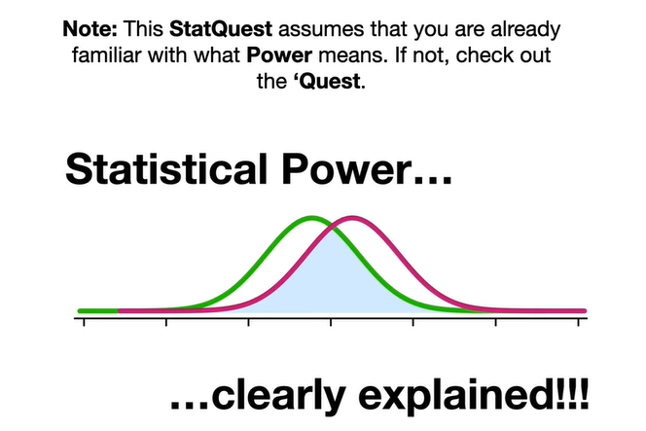

Note : this stat quest assumes that you are already familiar with what power means.

If not check out the quest.

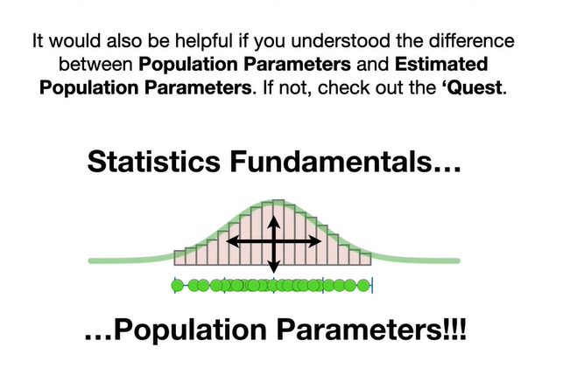

It would also be helpful if you understood the difference between population parameters and estimated population parameters.

If not check out the quest.

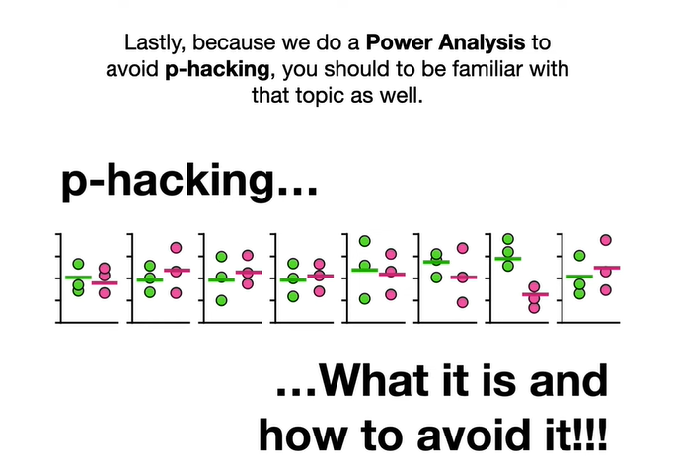

Lastly because we do a power analysis to avoid p hacking, you should be familiar with that topic as well.

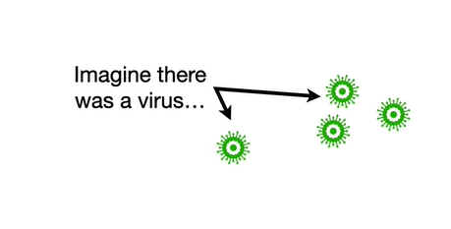

Imagine there was a virus

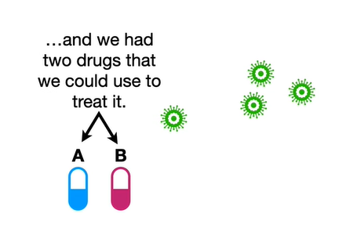

and we had two drugs that we could use to treat it.

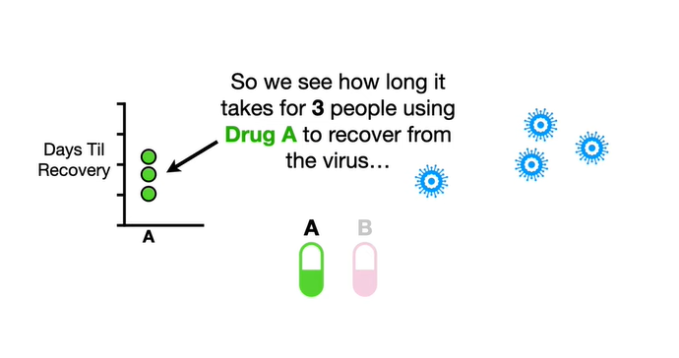

So we see how long it takes for three people using drug a to recover from the virus

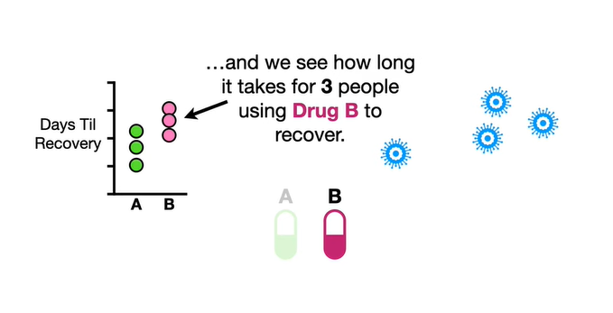

and we see how long it takes three people using drug b to recover.

Just looking at the data makes us think that drug a might be better since those people tended to recover from the virus more quickly.

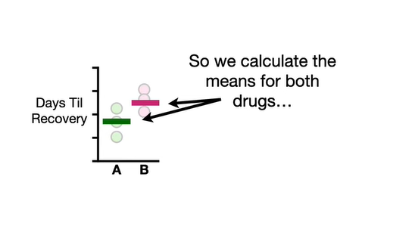

So we calculate the means for both drugs

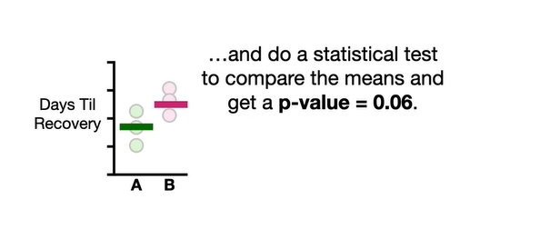

and do a statistical test to compare the means and get a p-value equal to 0.06.

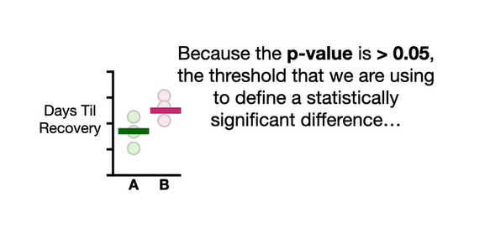

Because the p-value is greater than 0.05 the threshold that we are using to define a statistically significant difference

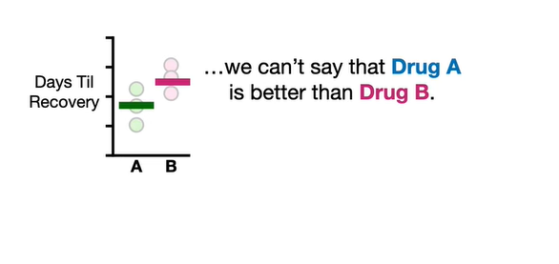

we can't say that drug a is better than drug b.

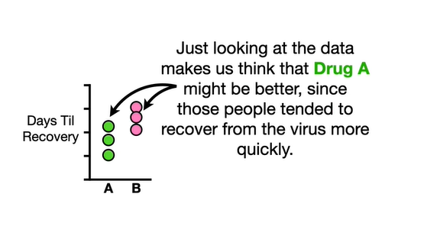

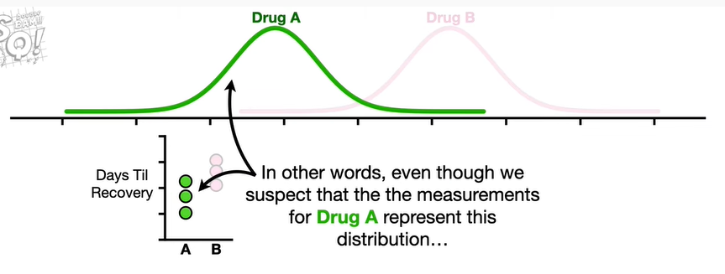

In other words even though we suspect that the measurements for drug a represent this distribution

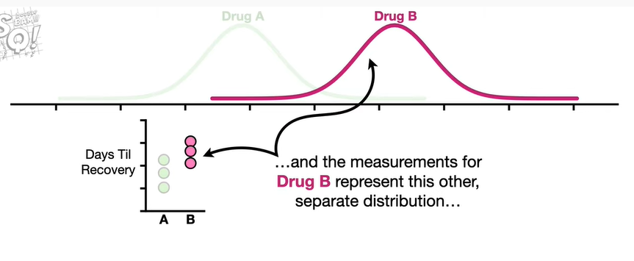

and the measurements for drug b represent this other separate distribution

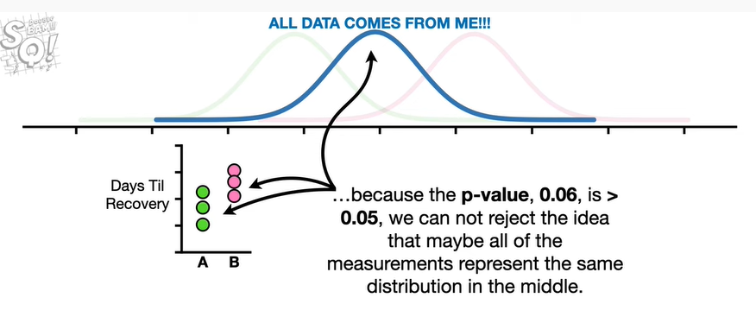

because the p-value 0.06 is greater than 0.05 we cannot reject the idea that maybe all of the measurements represent the same distribution in the middle.

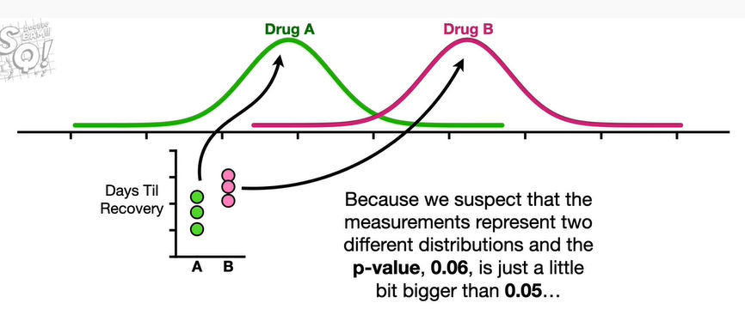

Because we suspect that the measurements represent two different distributions and the p-value 0.06 is just a little bit bigger than 0.05.

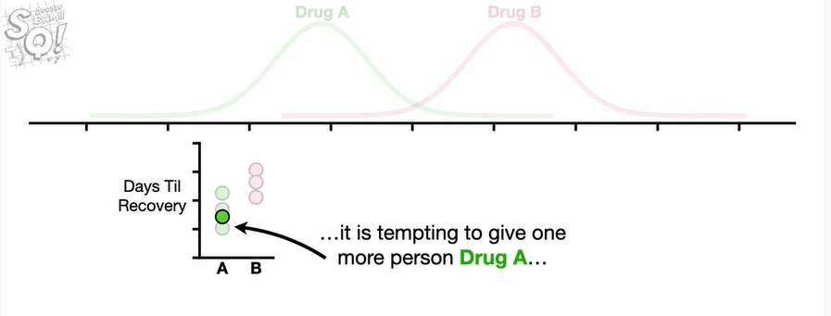

it is tempting to give one more person drug A and give another person drug b

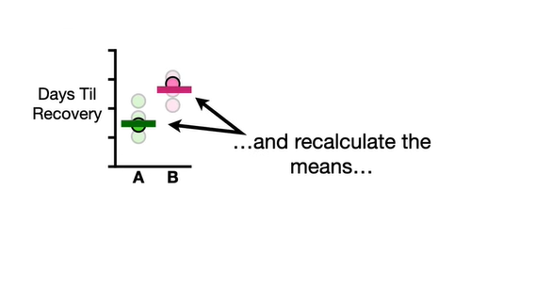

and recalculate the means

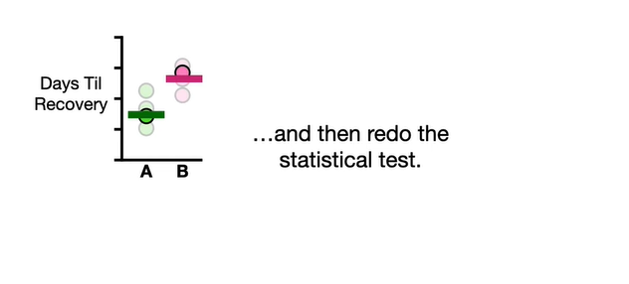

and then redo the statistical test.

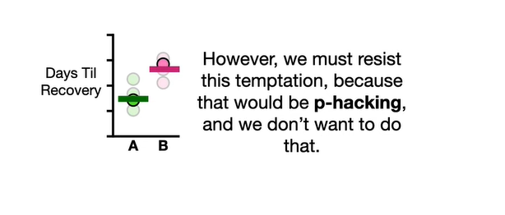

However we must resist this temptation because that would be p hacking and we don't want to do that.

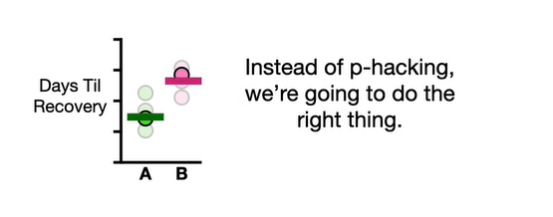

Instead of p hacking we're going to do the right thing.

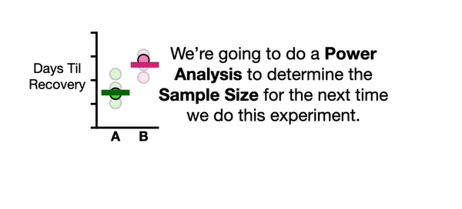

We're going to do a power analysis to determine the sample size for the next time we do this experiment.

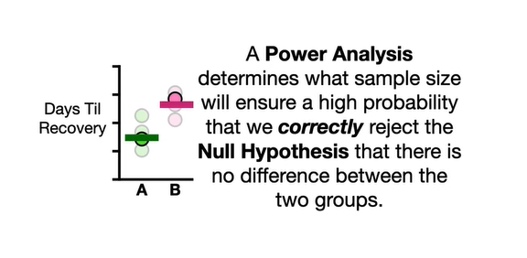

A power analysis determines what sample size will ensure a high probability that we will correctly reject the null hypothesis that there is no difference between the two groups.

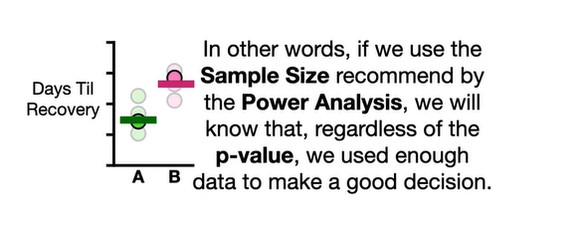

In other words if we use the sample size recommended by the power analysis we will know that regardless of the p-value we used enough data to make a good decision.

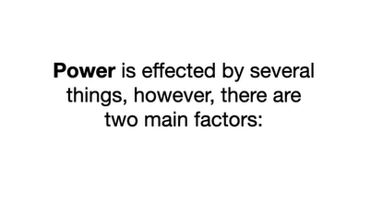

Power is affected by several things however there are two main factors :

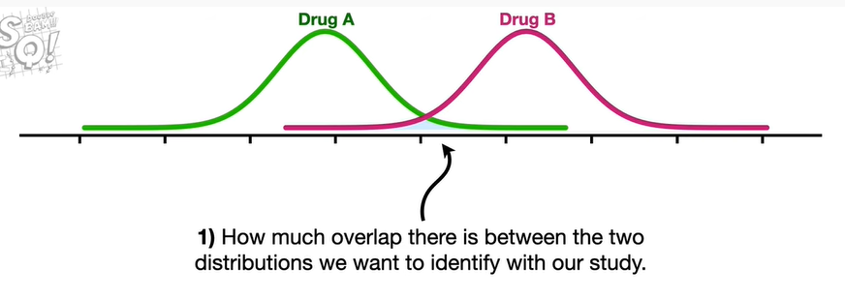

one how much overlap there is between the two distributions we want to identify with our study

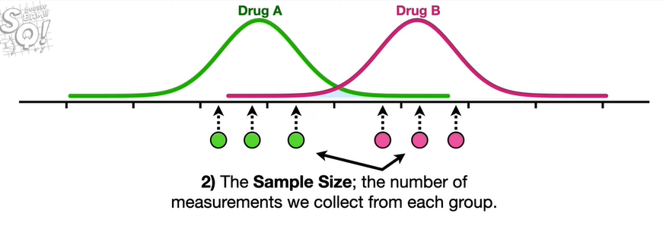

two the sample size the number of measurements we collect from each group.

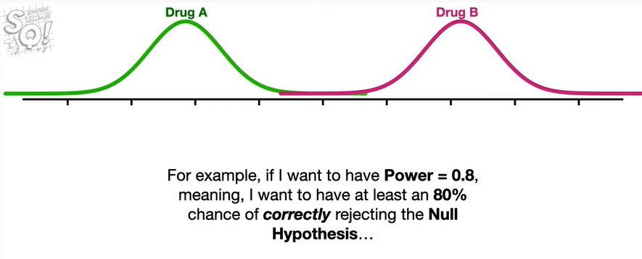

For example if i want to have power equal to 0.8 meaning i want to have at least an 80 chance of correctly rejecting the null hypothesis

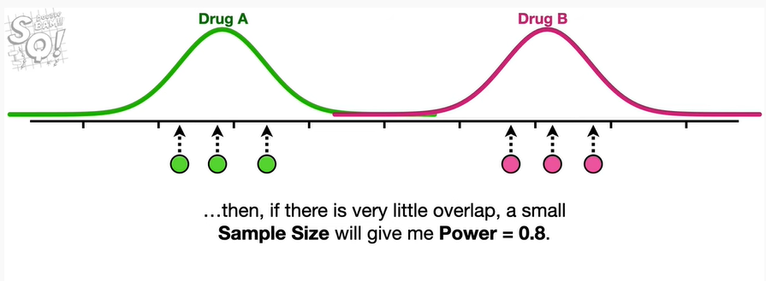

then if there is very little overlap a small sample size will give me power equal to 0.8.

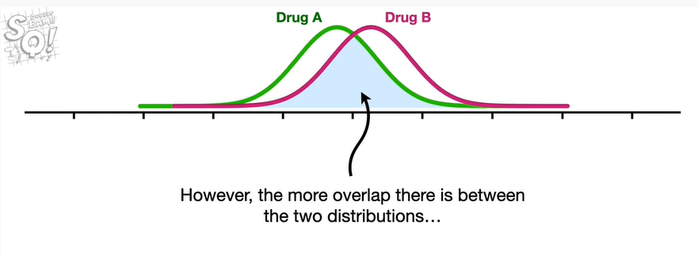

However the more overlap there is between the two distributions

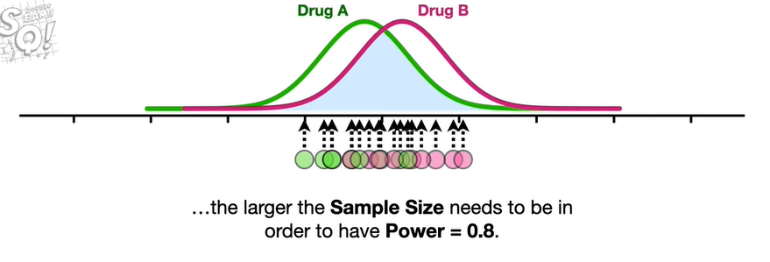

the larger the sample size needs to be in order to have power equal to 0.8.

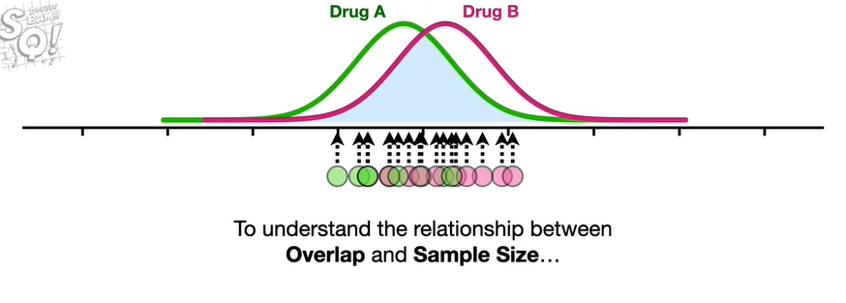

To understand the relationship between overlap and sample size

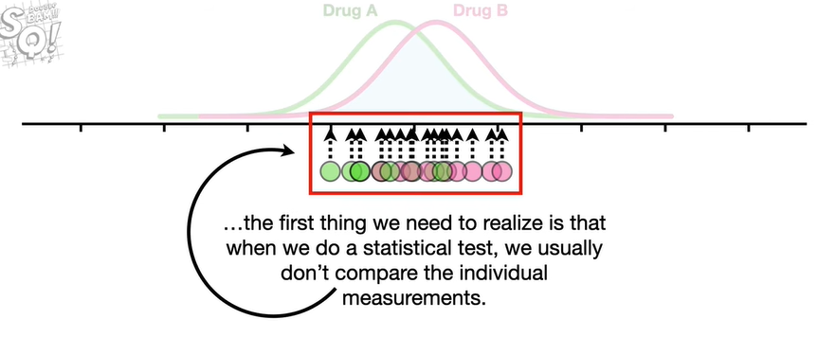

the first thing we need to realize is that when we do a statistical test we usually don't compare the individual measurements.

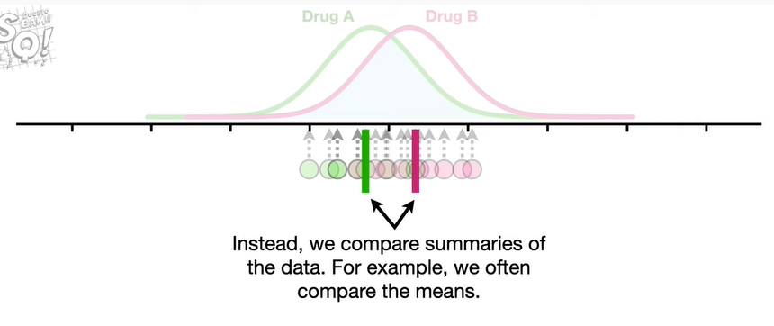

Instead we compare summaries of the data for example we often compare the means.

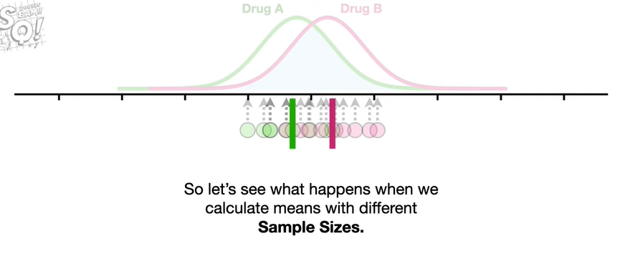

So let's see what happens when we calculate means with different sample sizes.

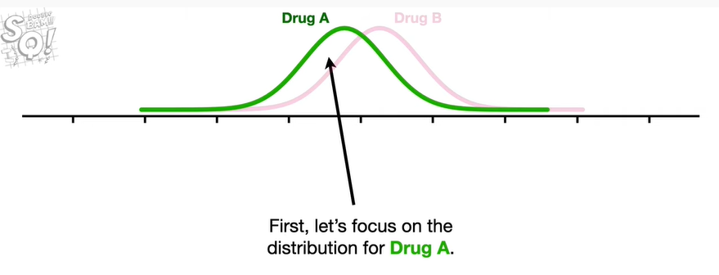

First let's focus on the distribution for drug A.

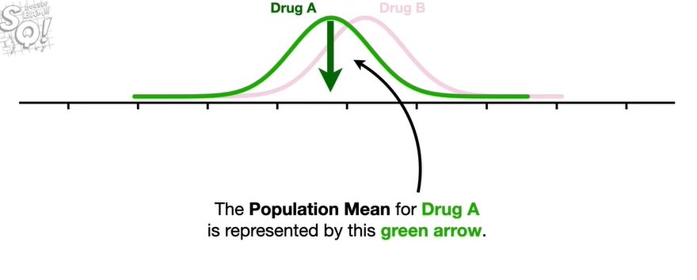

The population mean for drug A is represented by this green arrow.

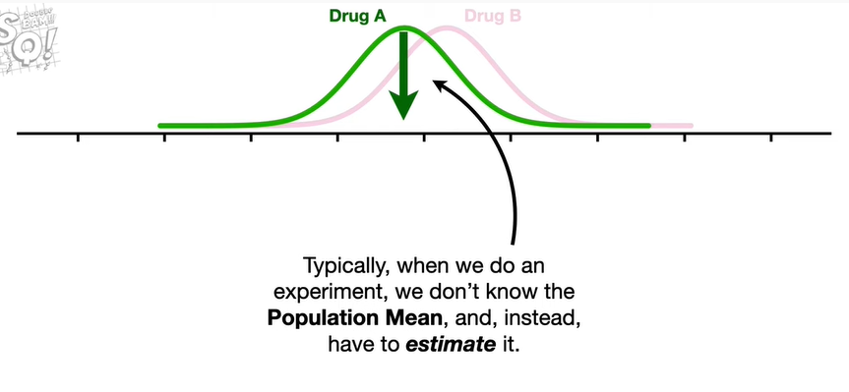

Typically when we do an experiment we don't know the population mean and instead have to estimate it.

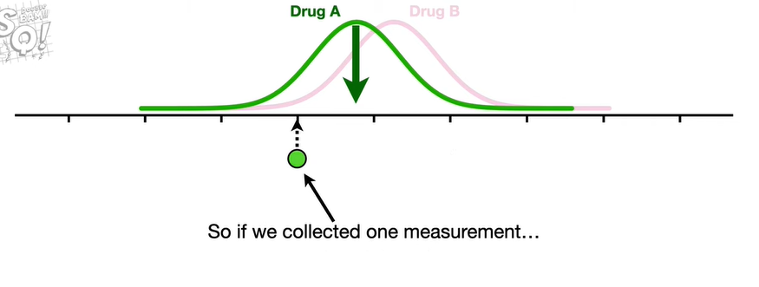

So if we collected one measurement and use that one measurement

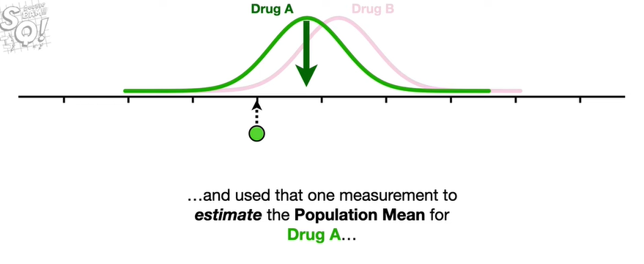

to estimate the population mean for drug A

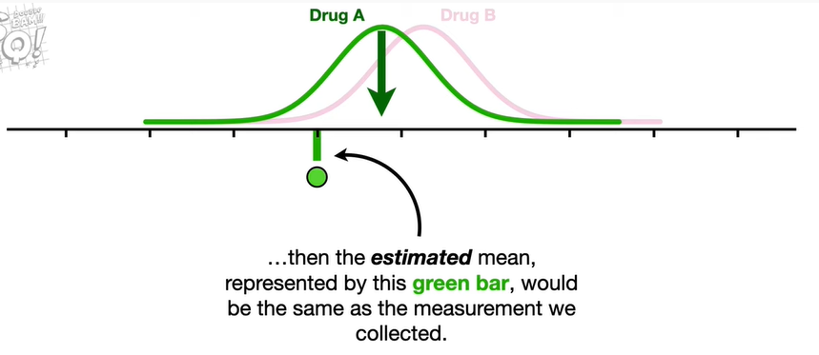

then the estimated mean represented by this green bar would be the same as the measurement we collected.

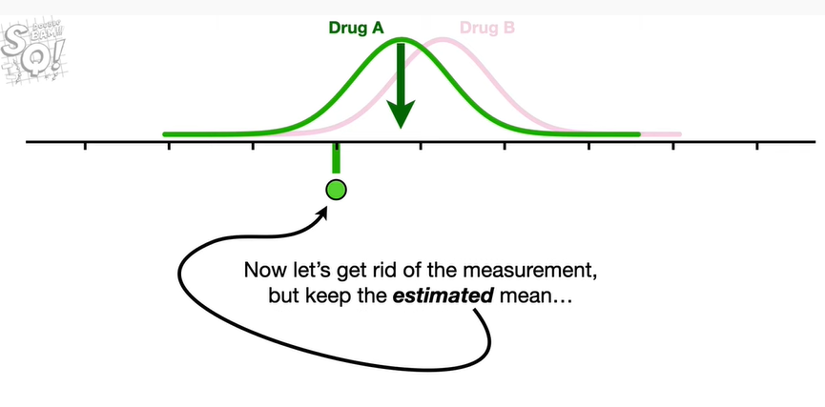

Now let's get rid of the measurement but keep the estimated mean

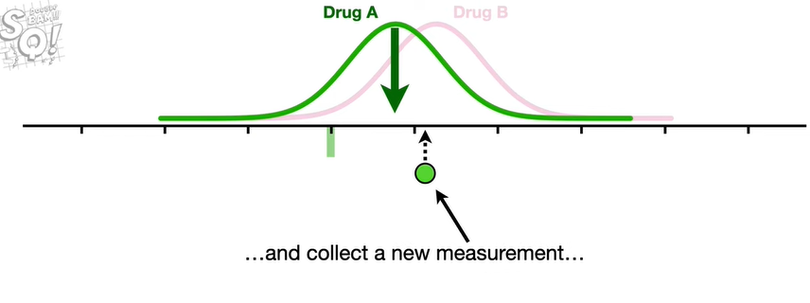

and collect a new measurement

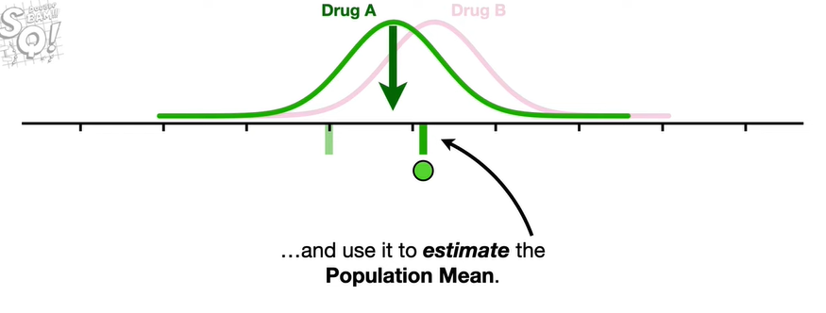

and use it to estimate the population mean.

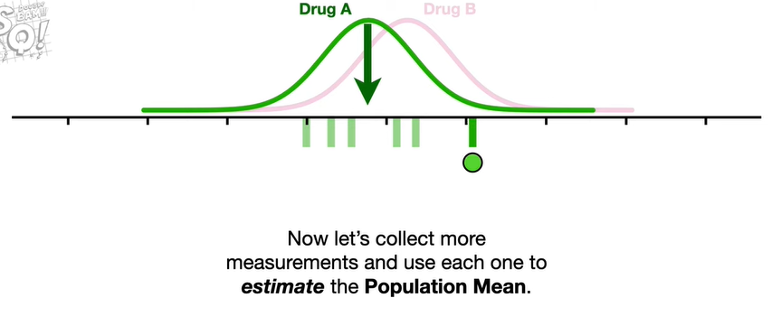

Now let's collect more measurements and use each one to estimate the population mean.

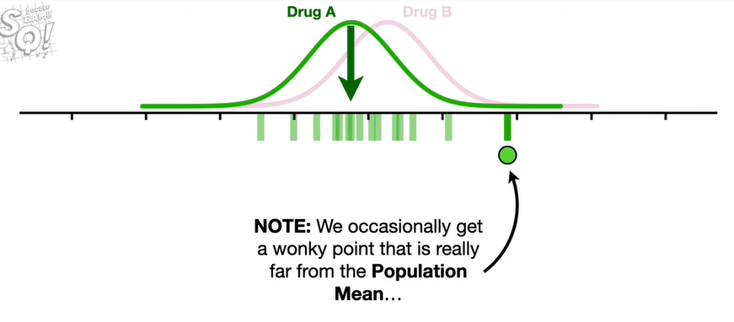

Note : we occasionally get a wonky point that is really far from the population mean

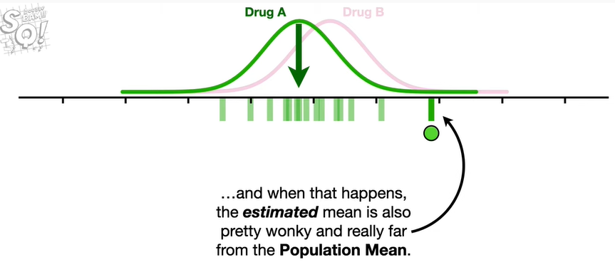

and when that happens the estimated mean is also pretty wonky and really far from the population mean.

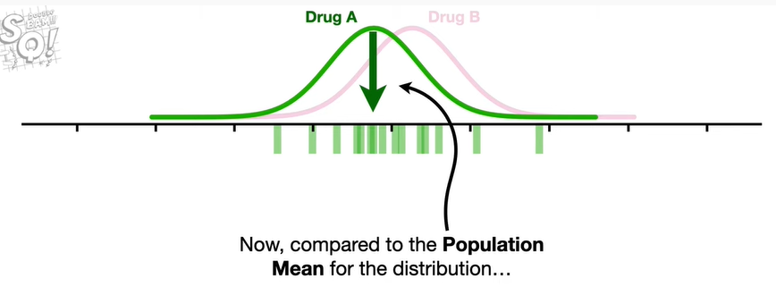

Now compared to the population mean for the distribution

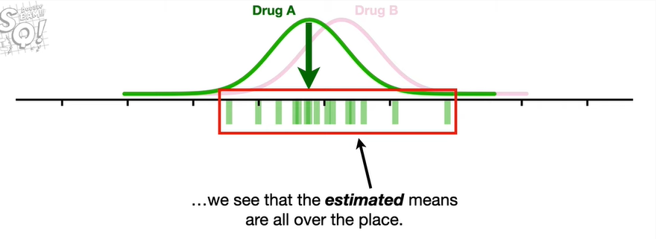

we see that the estimated means are all over the place.

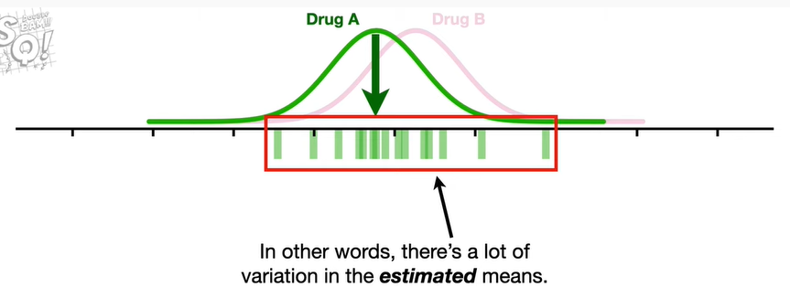

In other words there's a lot of variation in the estimated means.

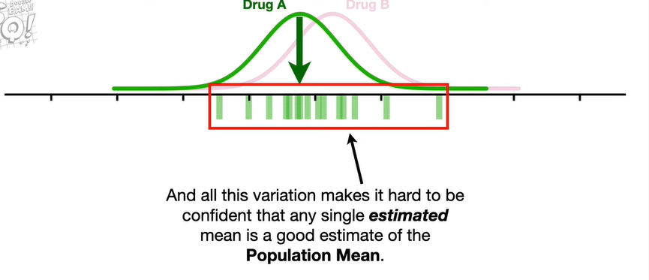

And all this variation makes it hard to be confident that any single estimated mean is a good estimate of the population mean.

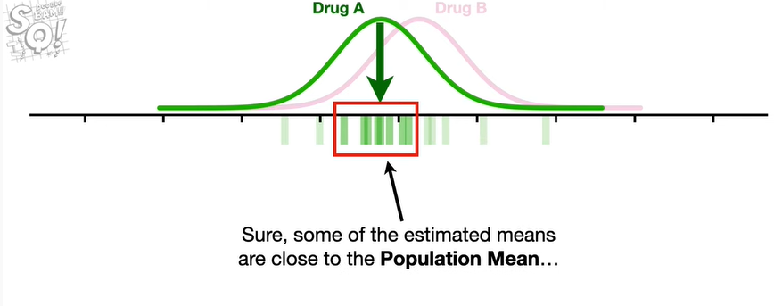

Sure some of the estimated means are close to the population mean

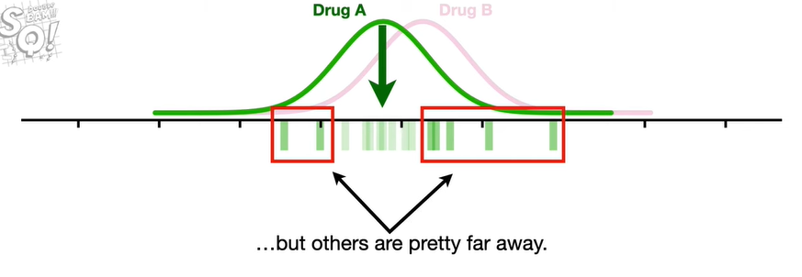

but others are pretty far away.

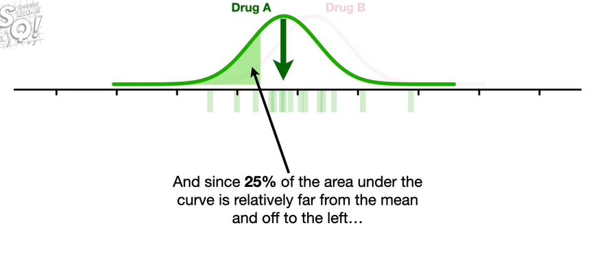

And since 25 of the area under the curve is relatively far from the mean and off to the left

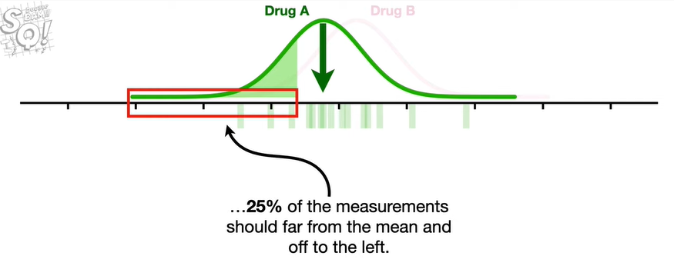

25 of the measurements should be far from the mean and off to the left

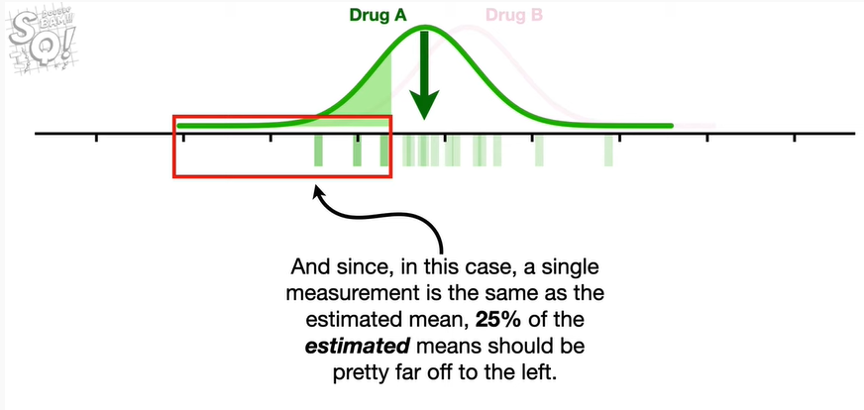

and since in this case a single measurement is the same as the estimated mean 25 percent of the estimated means should be pretty far off to the left.

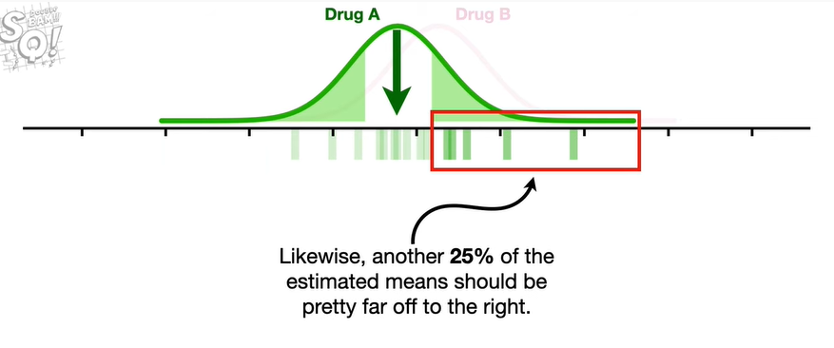

Likewise another 25 percent of the estimated means should be pretty far off to the right.

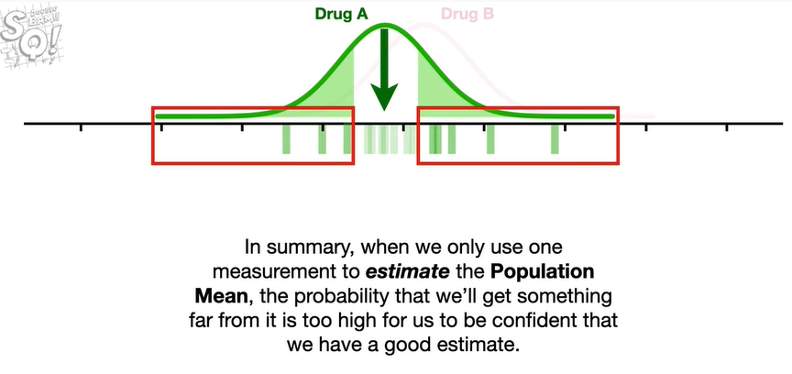

In summary when we only use one measurement to estimate the population mean the probability that we'll get something far from it is too high for us to be confident that we have a good estimate.

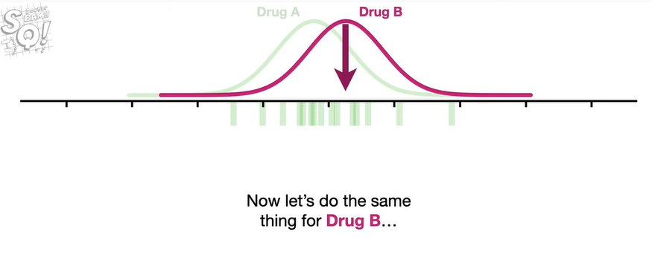

Now let's do the same thing for drug B

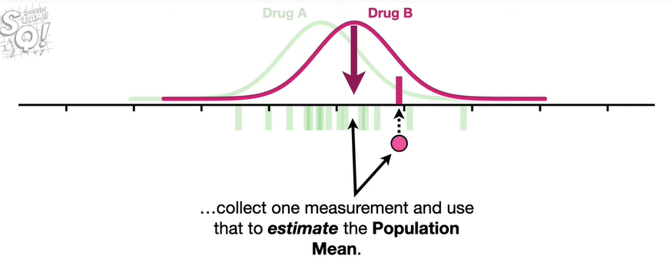

collect one measurement and use that to estimate the population mean.

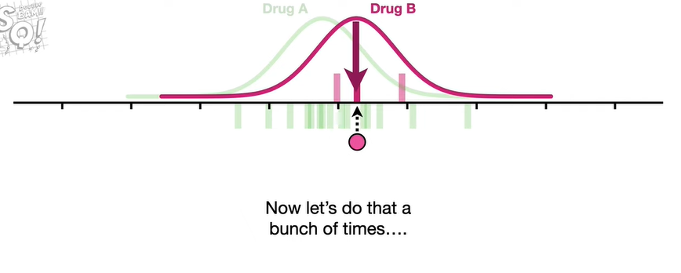

Now let's do that a bunch of times

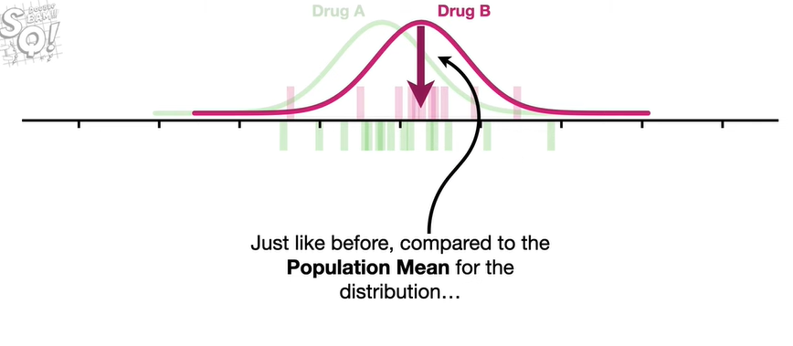

just like before compared to the population mean for the distribution

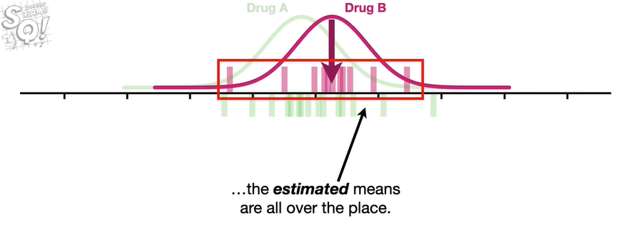

the estimated means are all over the place.

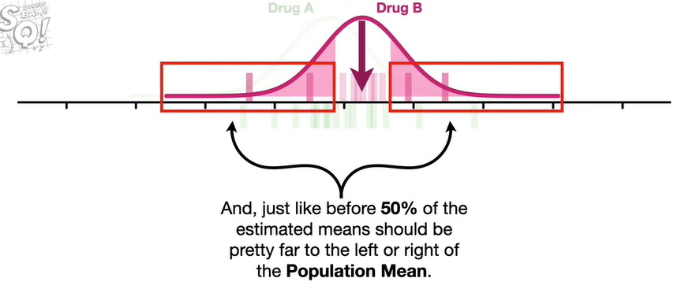

And just like before fifty percent of the estimated mean should be pretty far to the left or right of the population mean.

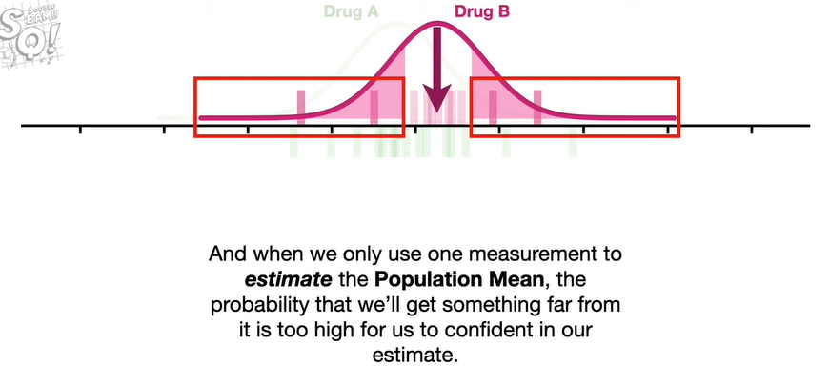

And when we only use one measurement to estimate the population mean the probability that we'll get something far from it is too high for us to be confident in our estimate.

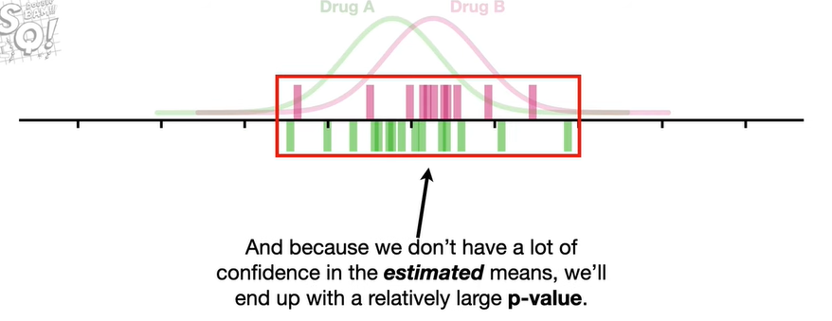

And because we don't have a lot of confidence in the estimated means we'll end up with a relatively large p-value.

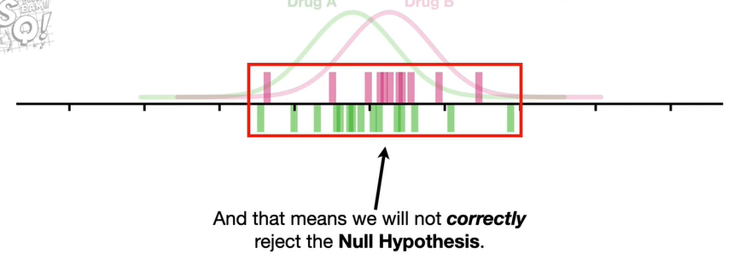

And that means we will not correctly reject the null hypothesis.

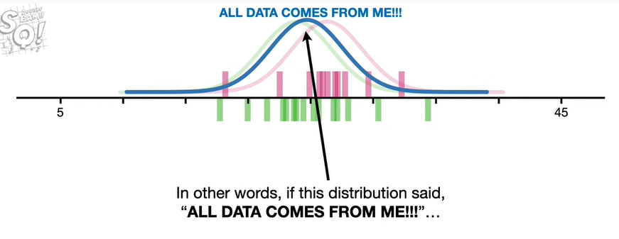

In other words if this distribution said all data comes from me

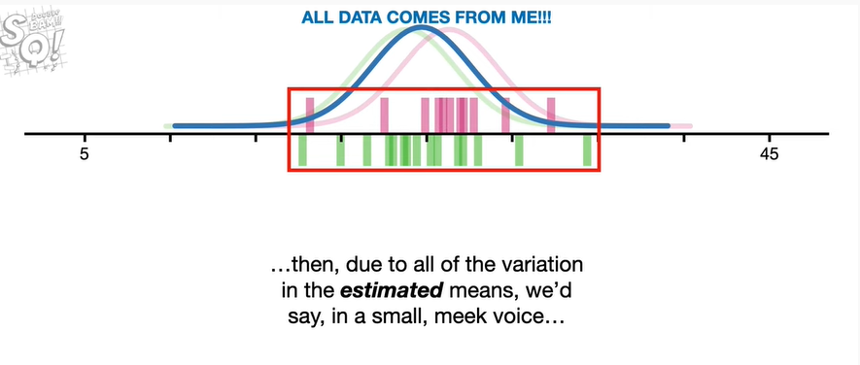

then due to all of the variation in the estimated means we'd say in a small meek voice

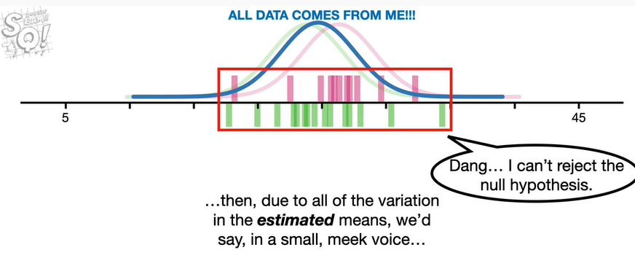

dang i can't reject the null hypothesis.

Bam !

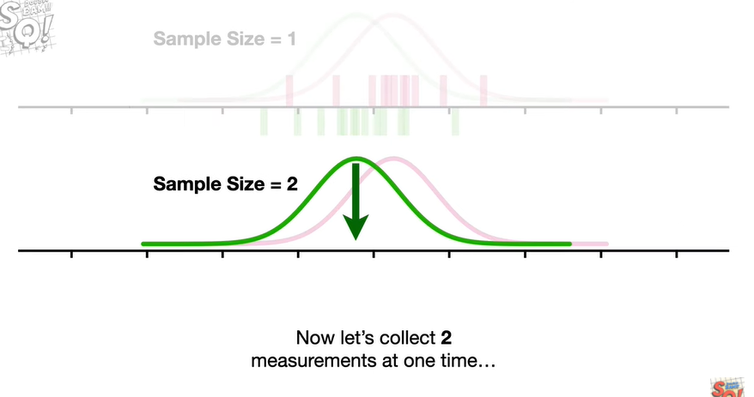

Now let's collect two measurements at one time

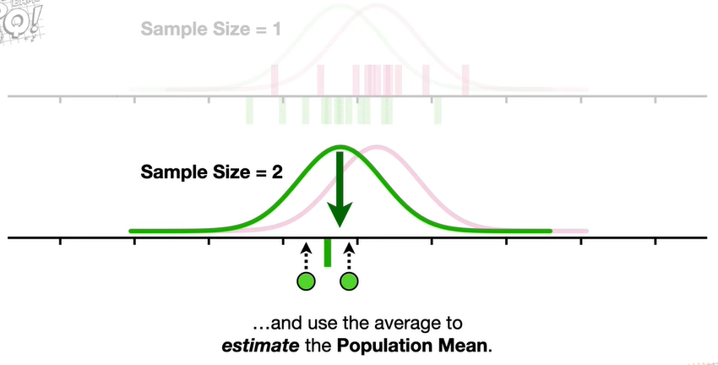

and use the average to estimate the population mean.

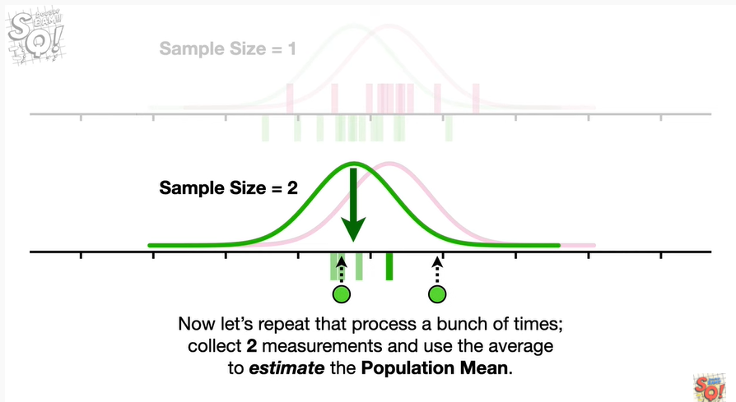

Now let's repeat that process a bunch of times collect two measurements and use the average to estimate the population mean.

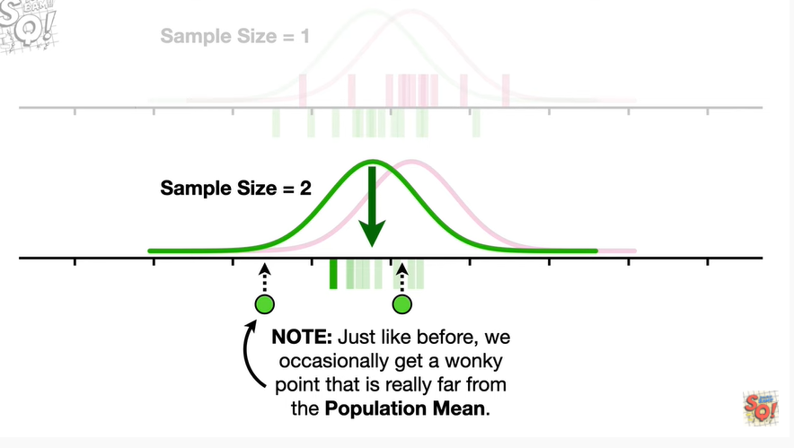

Note : just like before we occasionally get a wonky point that is really far from the population mean.

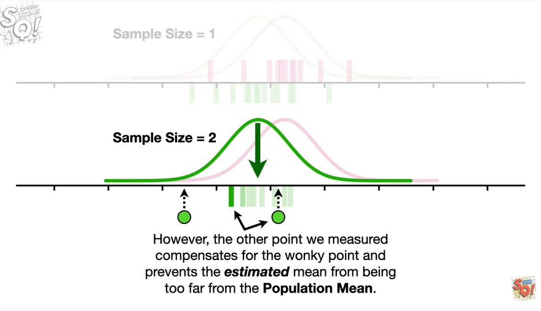

However the other point we measured compensates for the wonky point and prevents the estimated mean from being too far from the population mean.

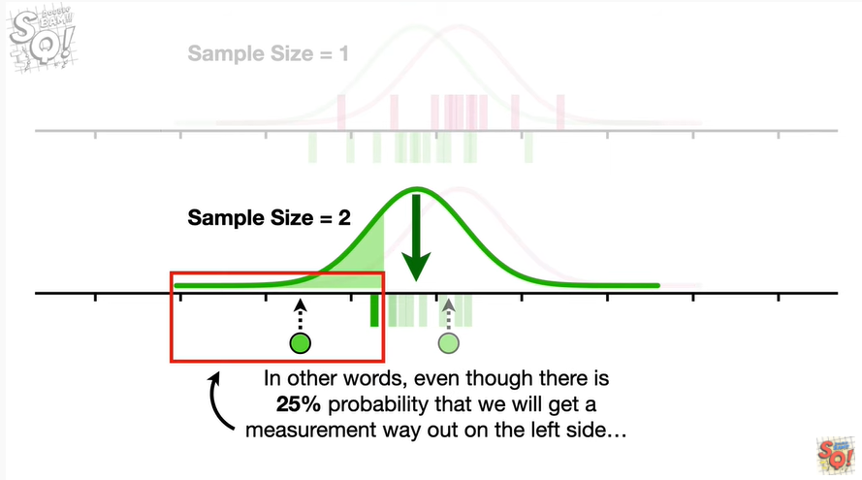

In other words even though there is a 25 probability that we will get a measurement way out on the left side

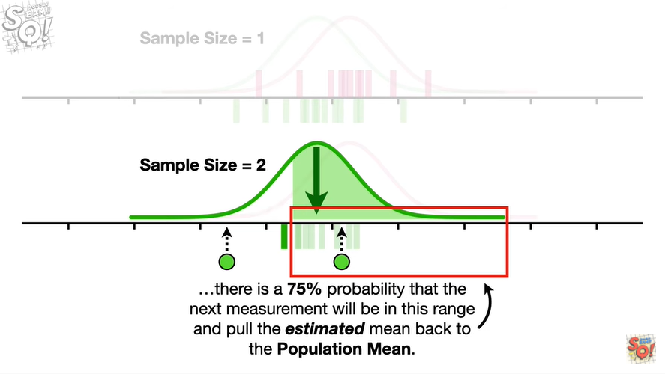

there is a 75 probability that the next measurement will be in this range and pull the estimated mean back to the population mean.

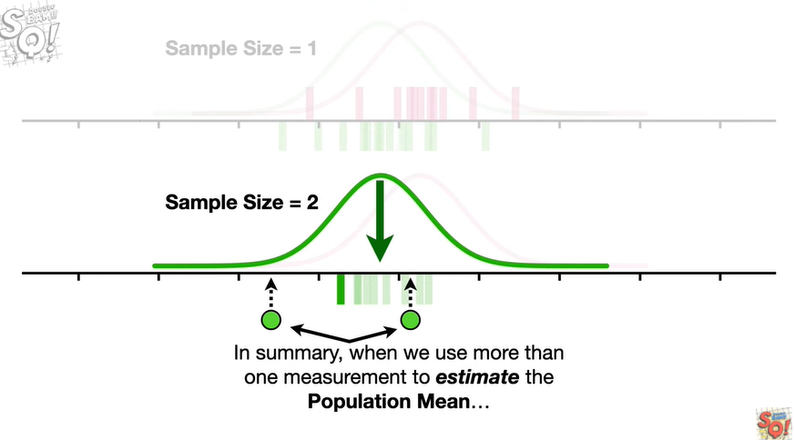

In summary when we use more than one measurement to estimate the population mean

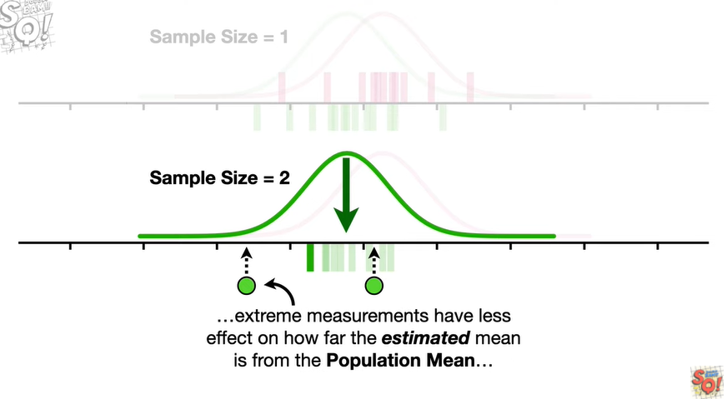

extreme measurements have less effect on how far the estimated mean is from the population mean

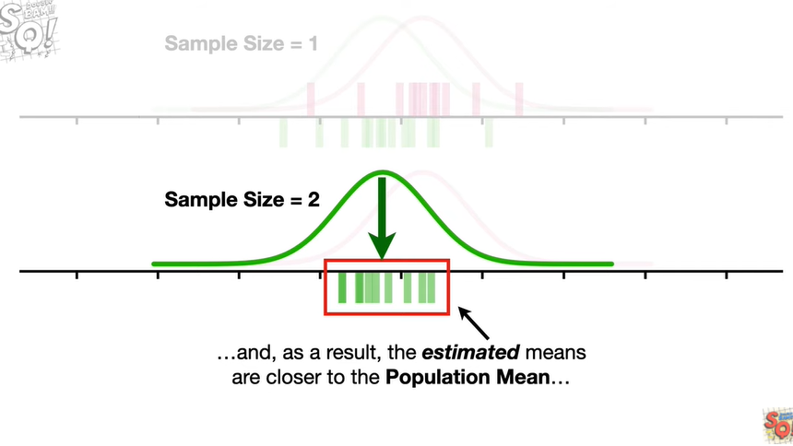

and as a result the estimated means are closer to the population mean

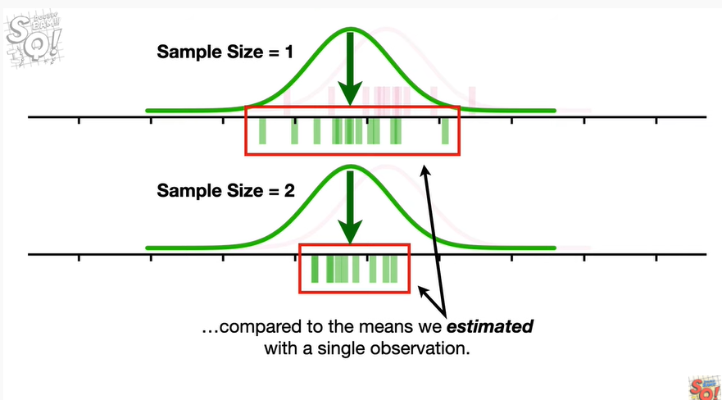

compared to the means we estimated with a single observation.

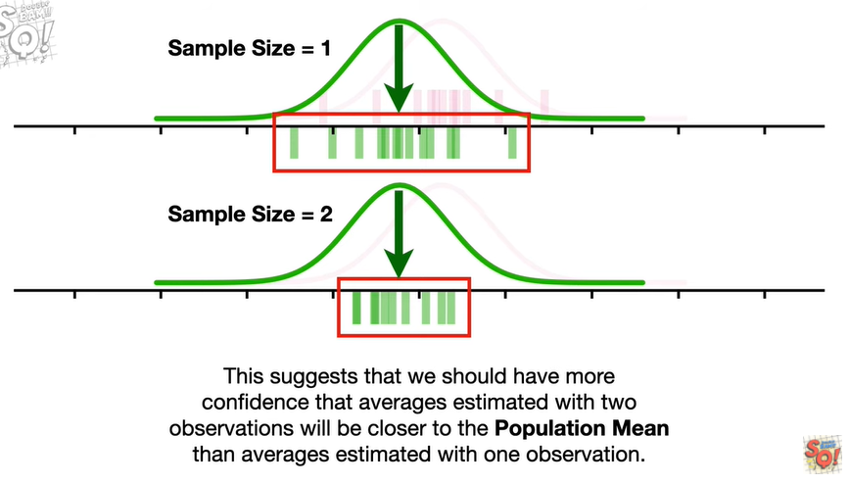

This suggests that we should have more confidence that averages estimated with two observations will be closer to the population mean than averages estimated with one observation.

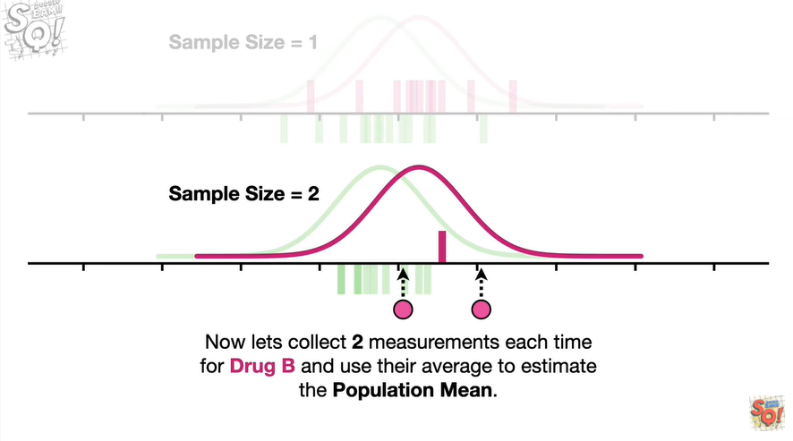

Now let's collect two measurements each time for drug b and use their average to estimate the population mean.

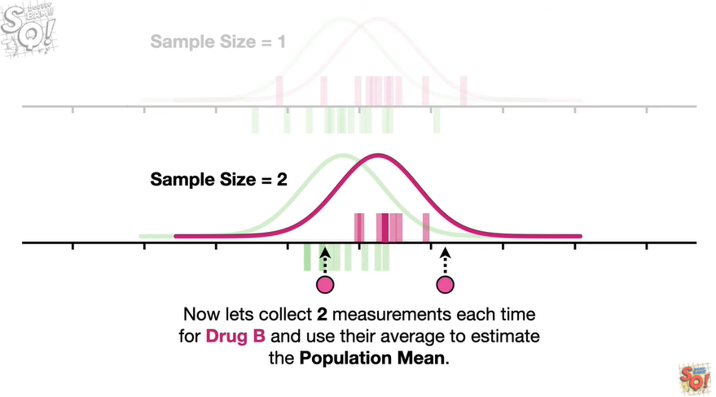

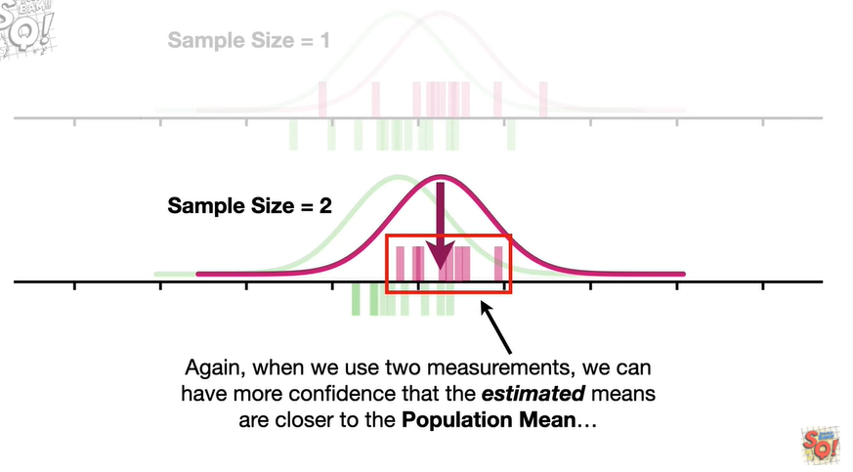

Again when we use two measurements we can have more confidence that the estimated means are closer to the population mean

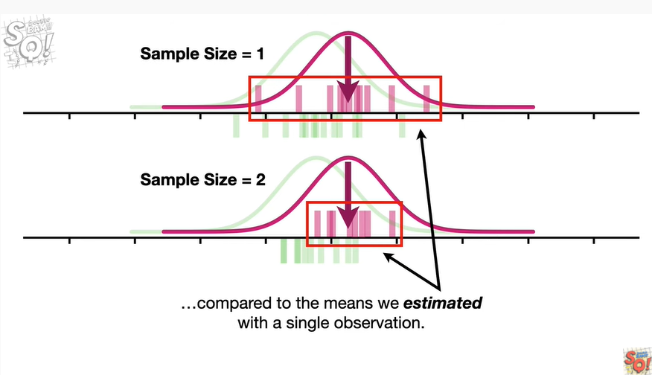

compared to the means we estimated with a single observation.

Bam !!!

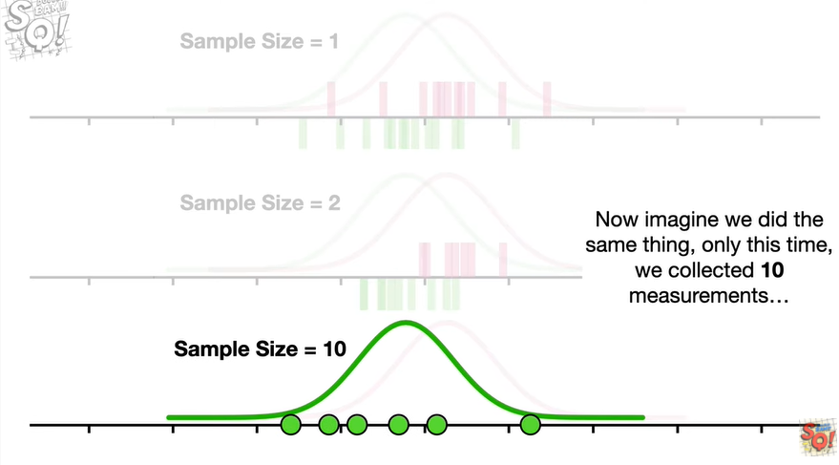

Now imagine we did the same thing only this time we collected 10 measurements

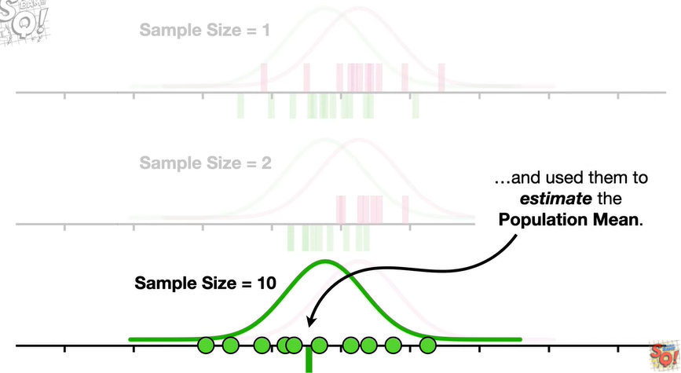

and used them to estimate the population mean.

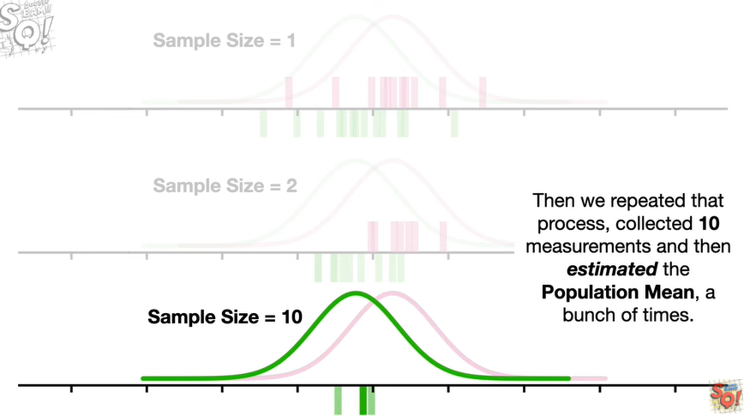

Then we repeated that process collected 10 measurements and then estimated the population mean a bunch of times

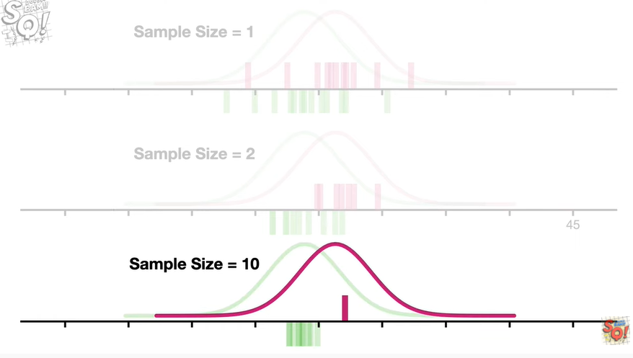

then we did the same thing for drug b.

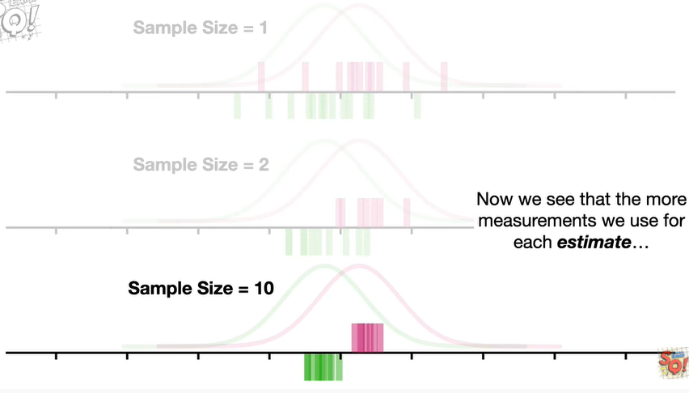

Now we see that the more measurements we use for each estimate the closer they are to the population main

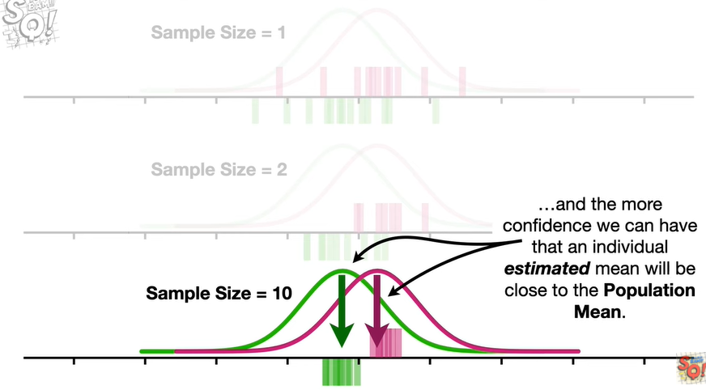

and the more confidence we can have that an individual estimated mean will be close to the population mean.

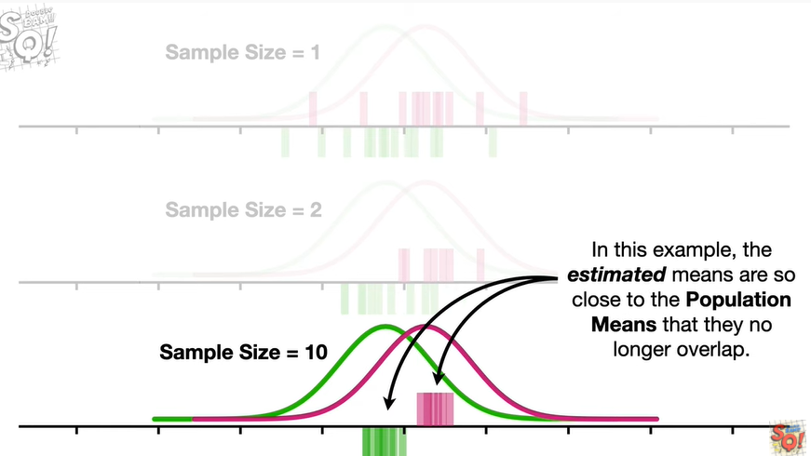

In this example the estimated means are so close to the population means that they no longer overlap.

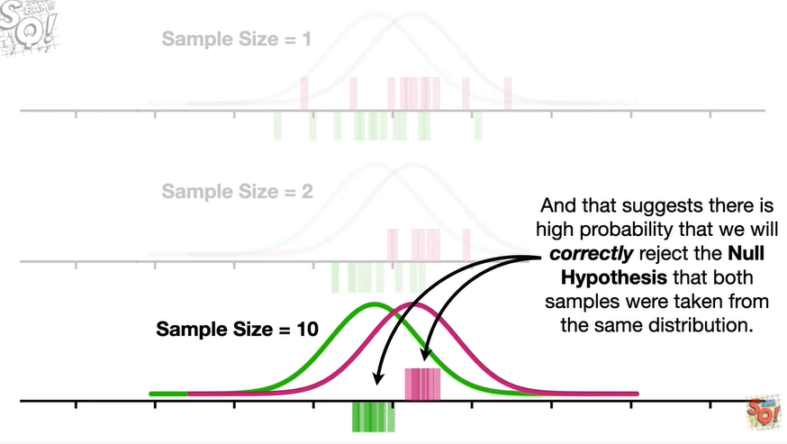

And that suggests there is a high probability that we will correctly reject the null hypothesis that both samples were taken from the same distribution.

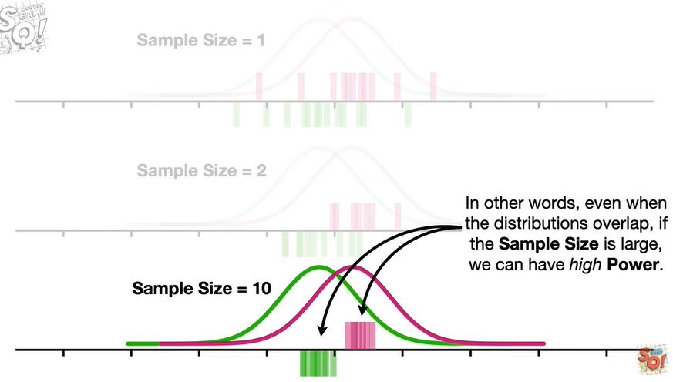

In other words even when the distributions overlap if the sample size is large we can have high power.

Bam !!

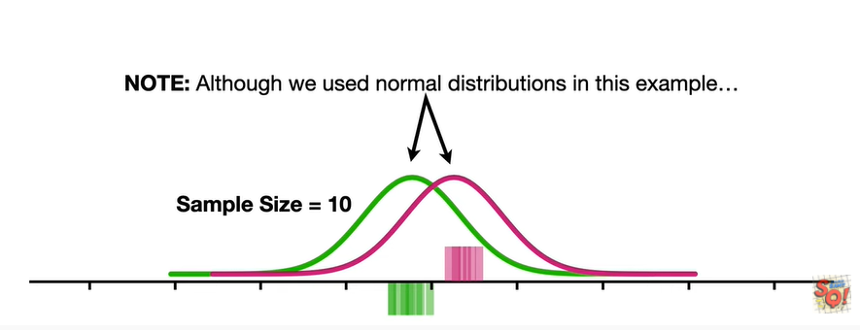

Note : although we used normal distributions in this example

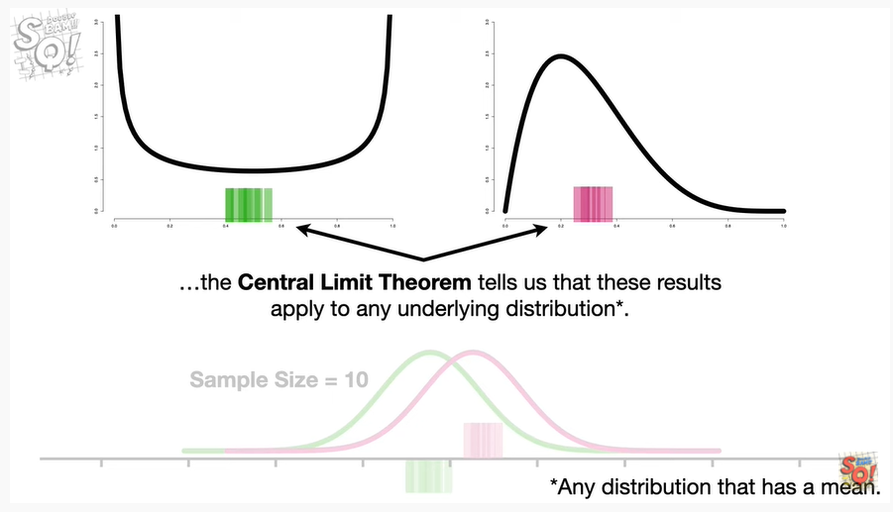

the central limit theorem tells us that these results apply to any underlying distribution.

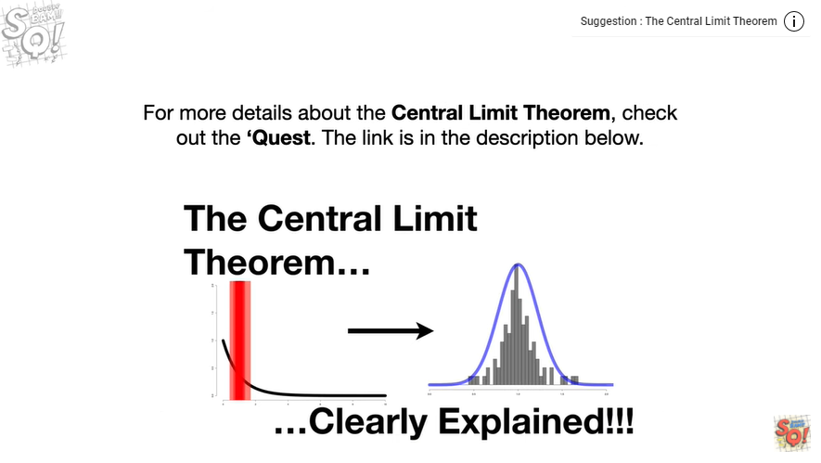

Shameless self-promotion.

For more details about the central limit theorem check out the quest.

The link is in the description below.

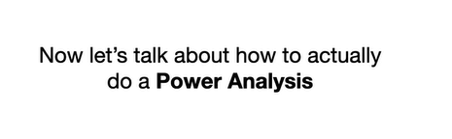

Now at long last let's talk about how to actually do a power analysis.

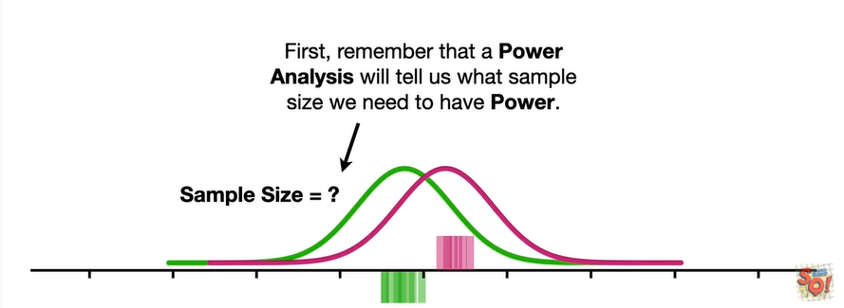

First remember that a power analysis will tell us what sample size we need to have power.

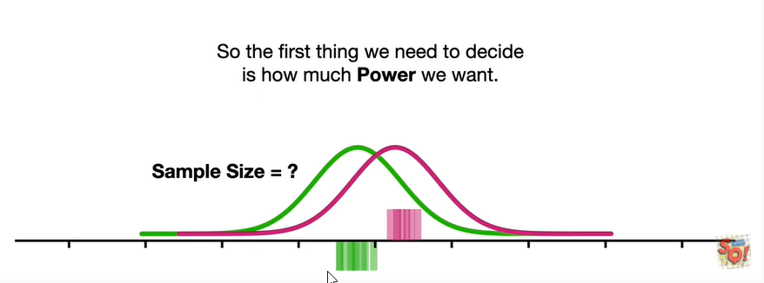

So the first thing we need to decide is how much power we want.

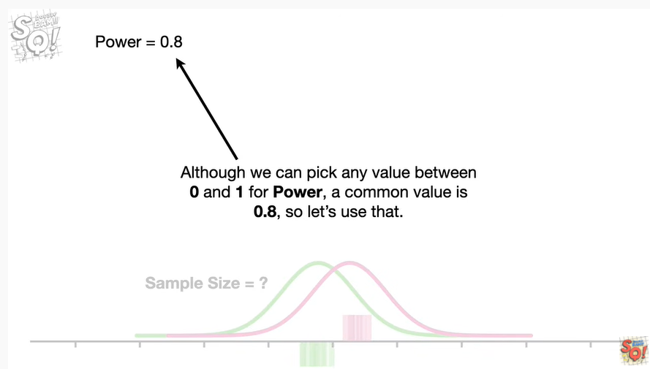

Although we can pick any value between 0 and 1 for power a common value is 0.8 so let's use that.

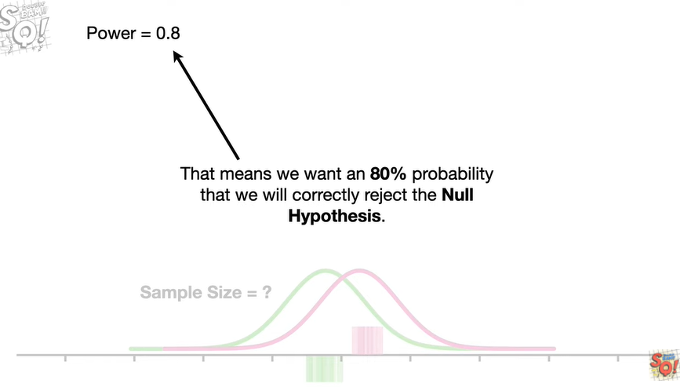

That means we want an 80 probability that we will correctly reject the null hypothesis.

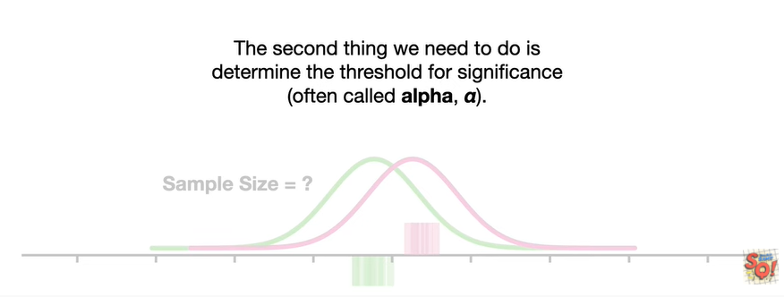

The second thing we need to do is determine the threshold for significance often called alpha.

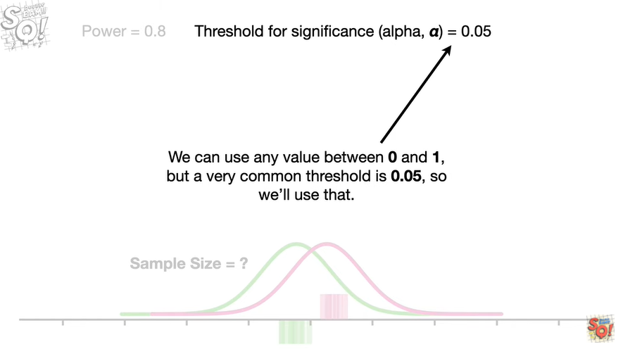

We can use any value between 0 and 1 but a very common threshold is 0.05 so we'll use that.

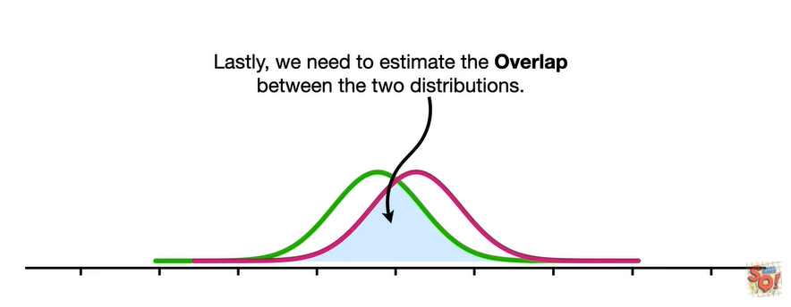

Lastly we need to estimate the overlap between the two distributions.

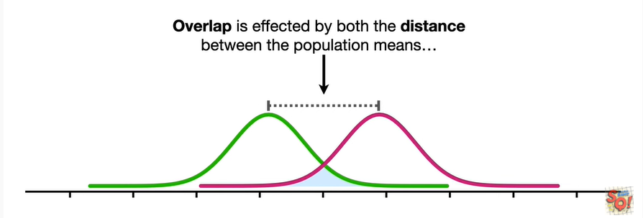

Overlap is affected by both the distance between the population means

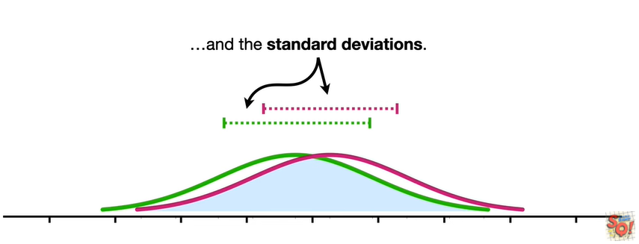

and the standard deviations.

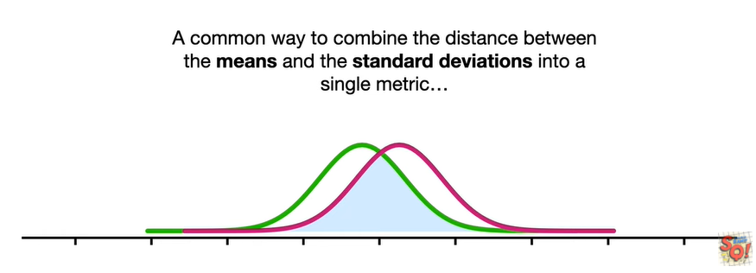

A common way to combine the distance between the means and the standard deviations into a single metric

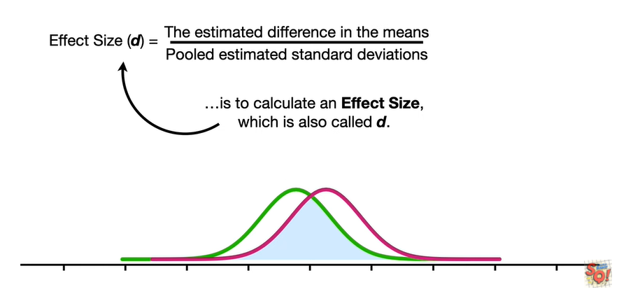

is to calculate an effect size which is also called d.

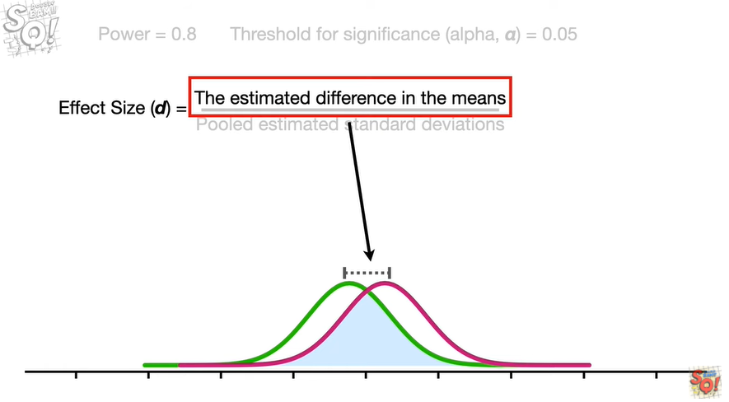

In the numerator we have the estimated difference in the means

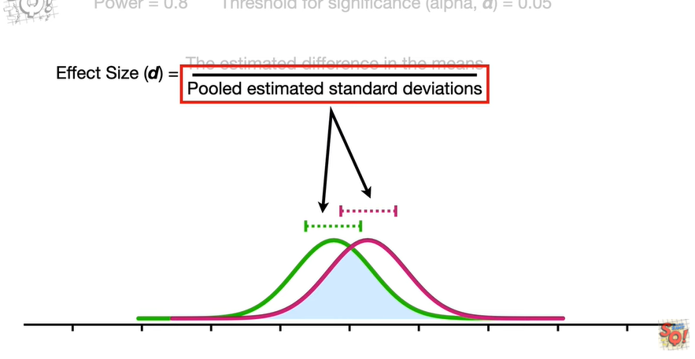

and in the denominator we have the pooled estimated standard deviations.

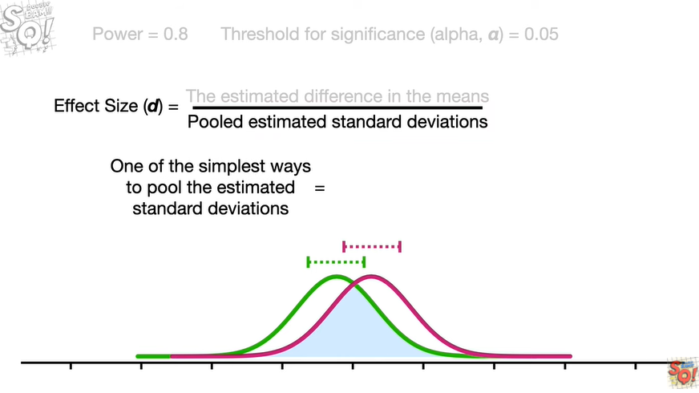

One of the simplest ways to pool the estimated standard deviations

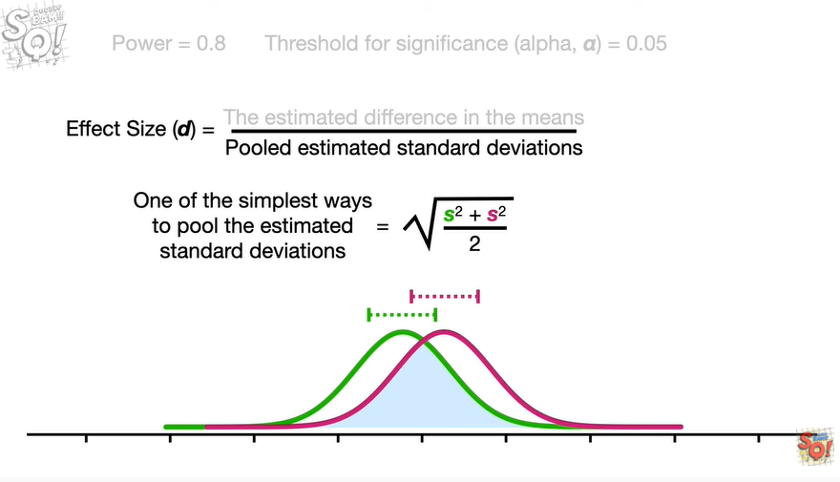

is the square root of the sum of the squared standard deviations divided by 2

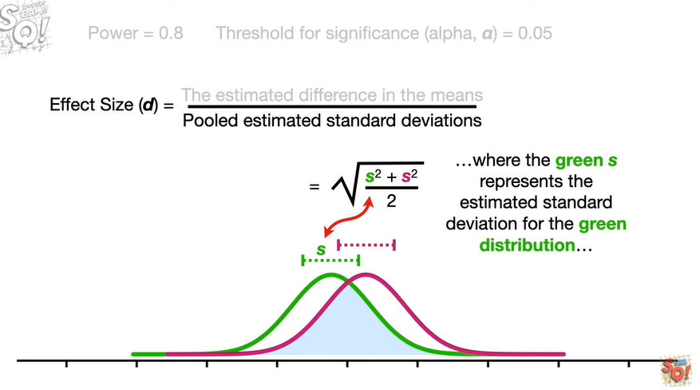

where the green s represents the estimated standard deviation for the green distribution

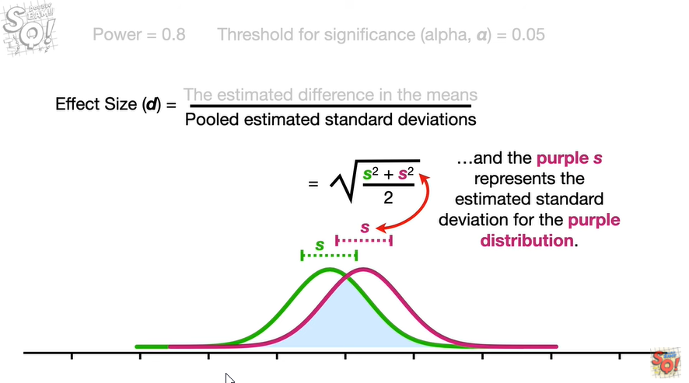

and the purple s represents the estimated standard deviation for the purple distribution.

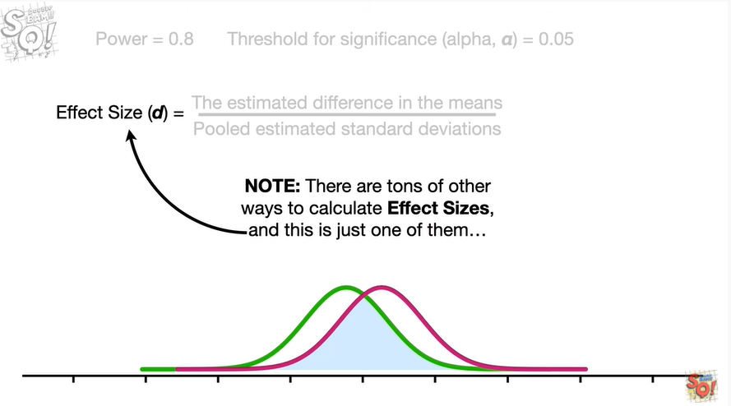

Note : there are tons of other ways to calculate effect sizes and this is just one of them

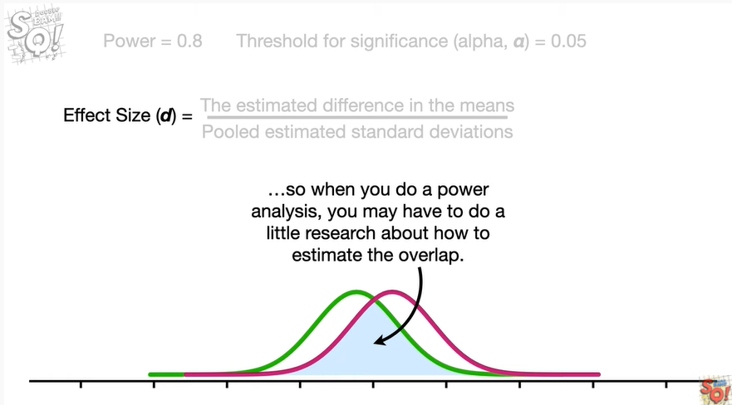

so when you do a power analysis you may have to do a little research about how to estimate the overlap.

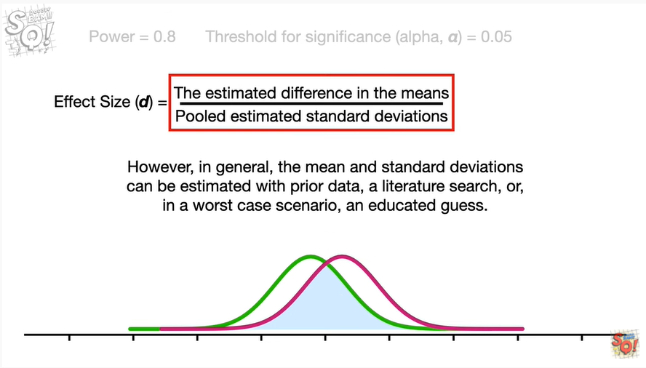

However in general the mean and standard deviations can be estimated with prior data a literature search or in a worst case scenario an educated guess.

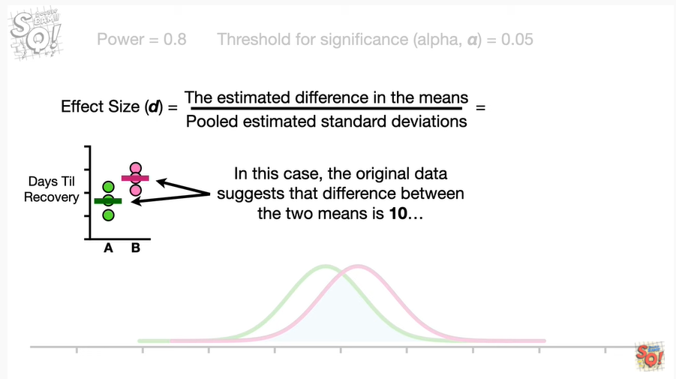

In this case the original data suggests that the difference between the two means is ten

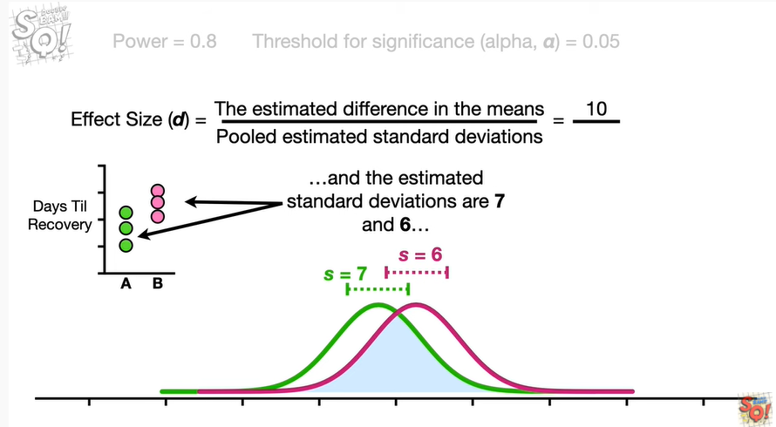

and the estimated standard deviations are seven and six

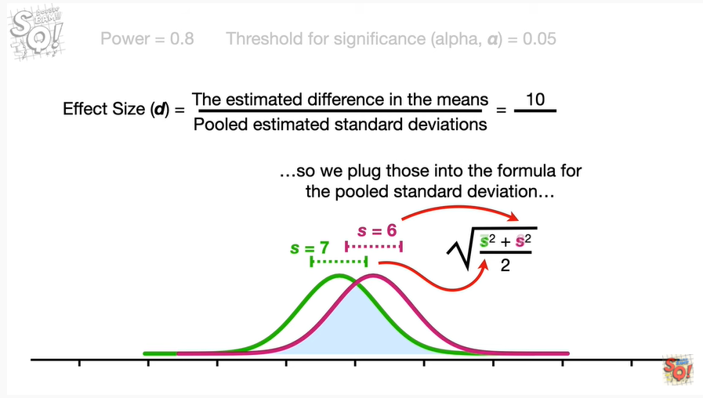

so we plug those into the formula for the pooled standard deviation

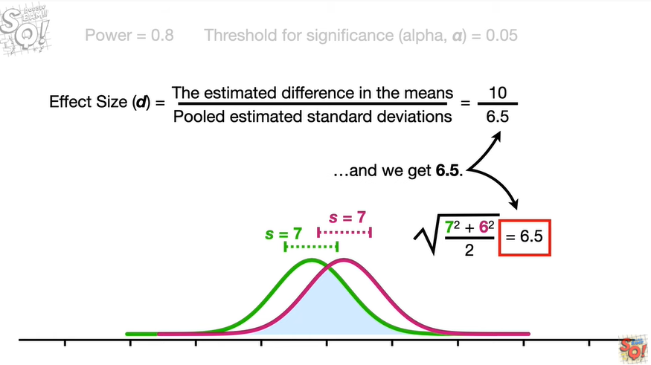

and we get six point five

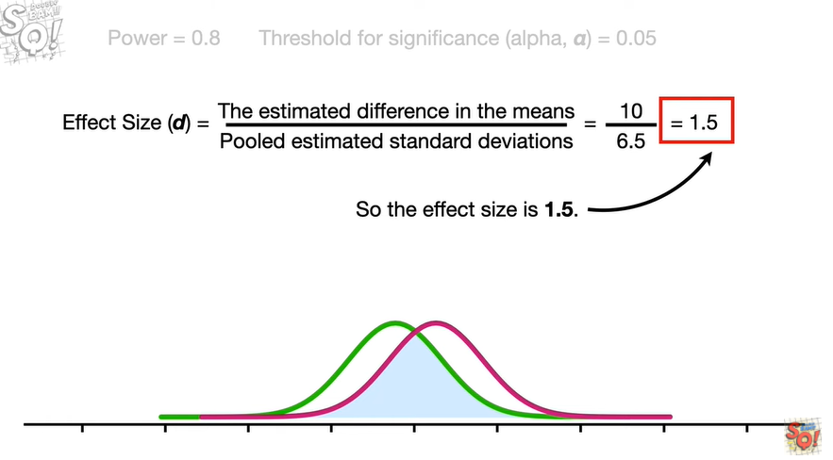

so the effect size is 1.5.

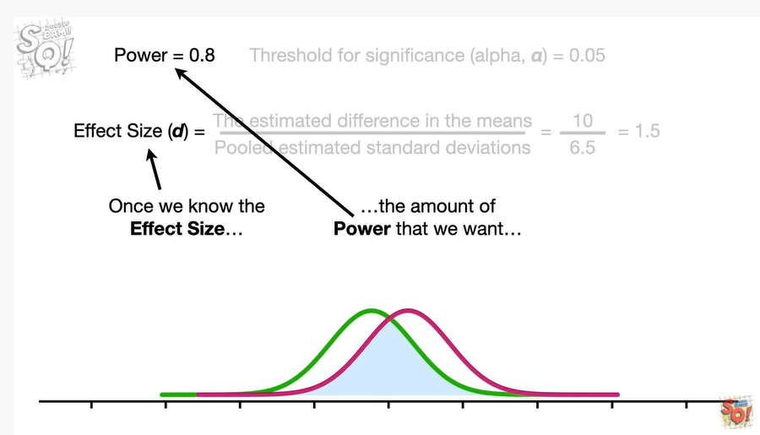

Once we know the effect size and the amount of power we want and the threshold for significance

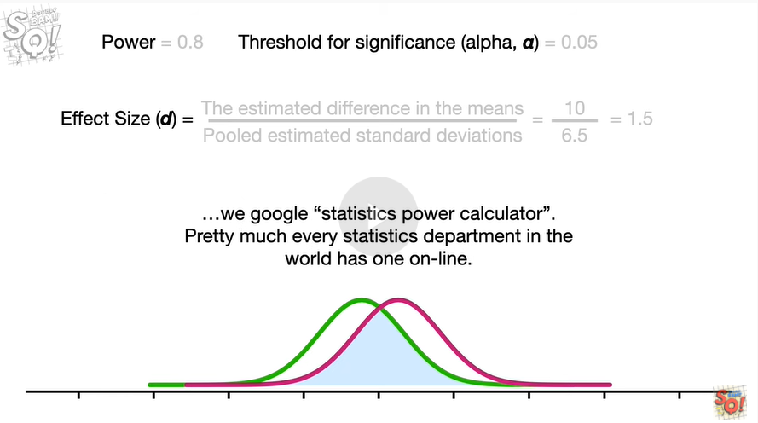

we google statistics power calculator pretty much every statistics department in the world has one online.

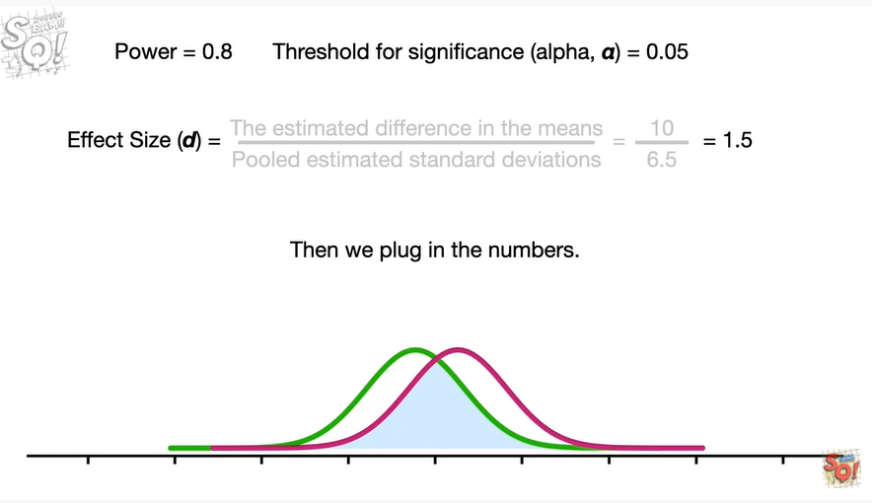

Then we plug in the numbers.

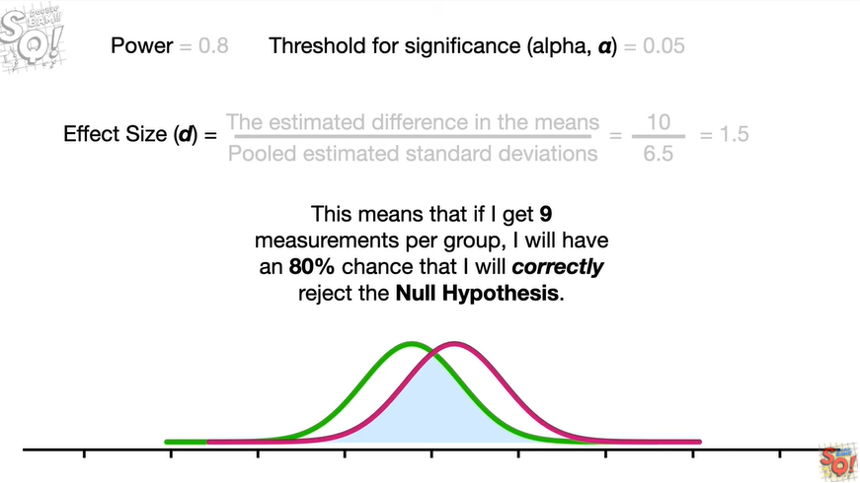

I got sample size equals nine this means that if i get nine measurements per group i will have an eighty percent chance that i will correctly reject the null hypothesis.

Double bam !!!

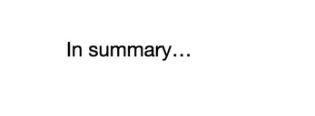

In summary

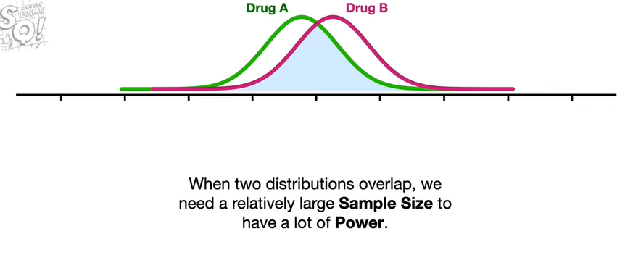

when two distributions overlap we need a relatively large sample size to have a lot of power.

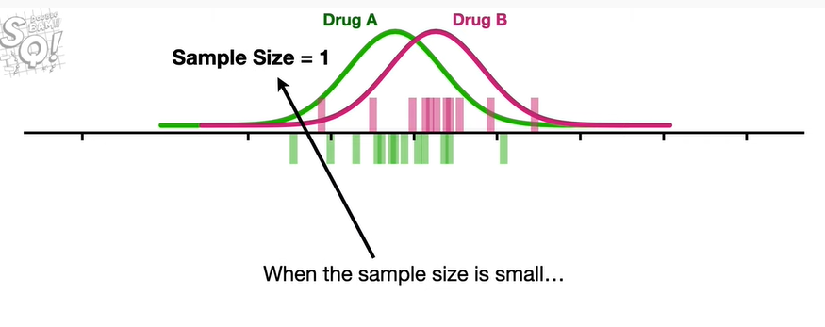

When the sample size is small

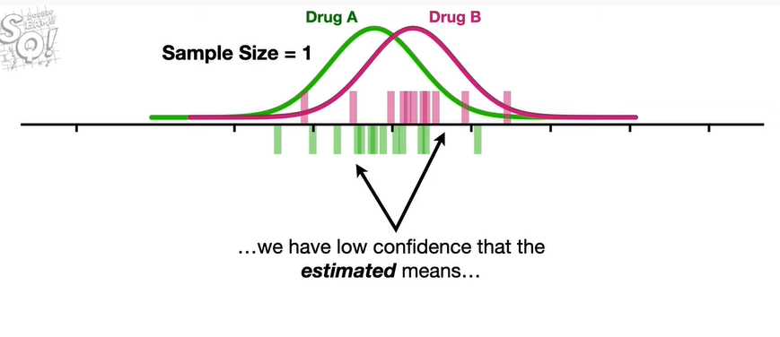

we have low confidence that the estimated means

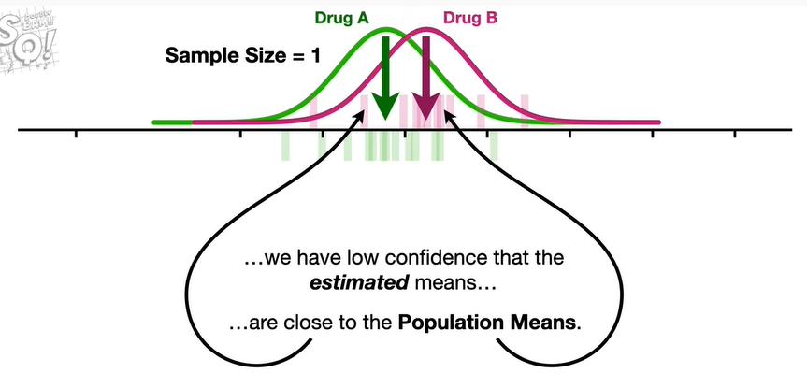

are close to the population means

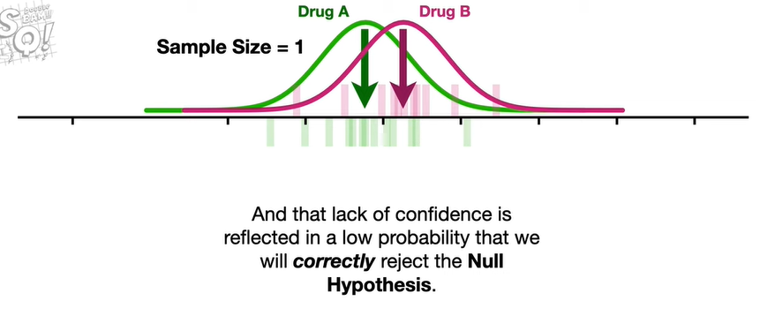

and that lack of confidence is reflected in a low probability that we will correctly reject the null hypothesis.

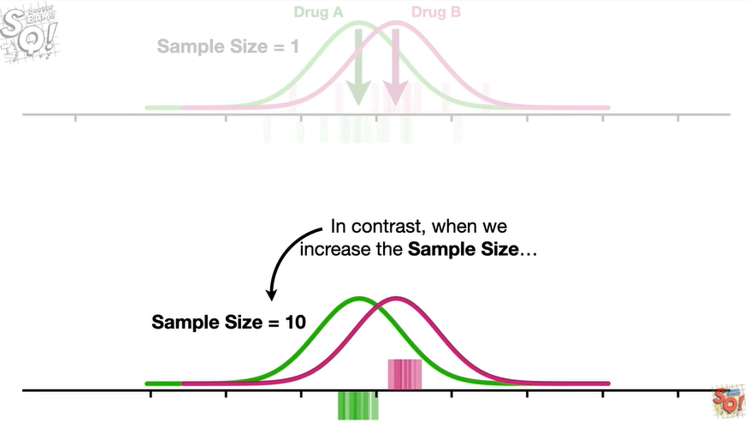

In contrast when we increase the sample size

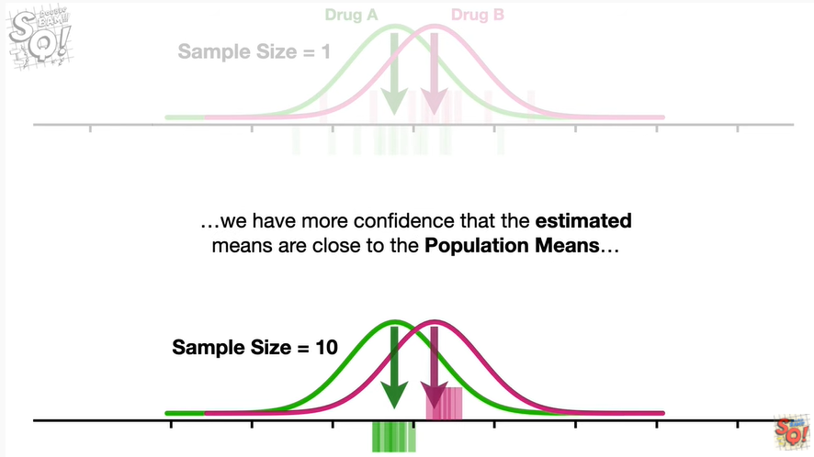

we have more confidence that the estimated means are close to the population means

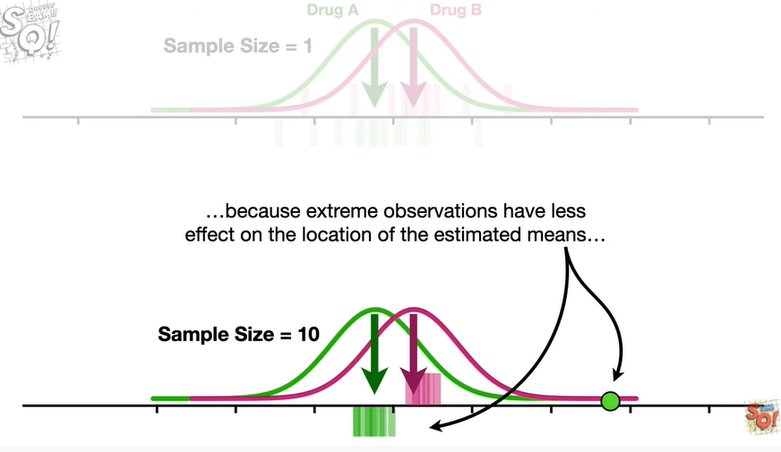

because extreme observations have less effect on the location of the estimated means

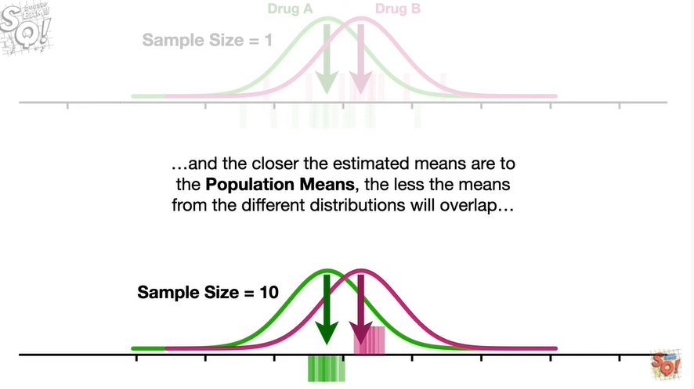

and the closer the estimated means are to the population means the less the means from the different distributions will overlap

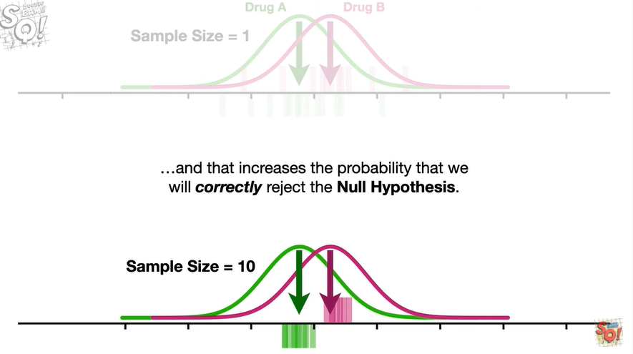

and that increases the probability that we will correctly reject the null hypothesis.

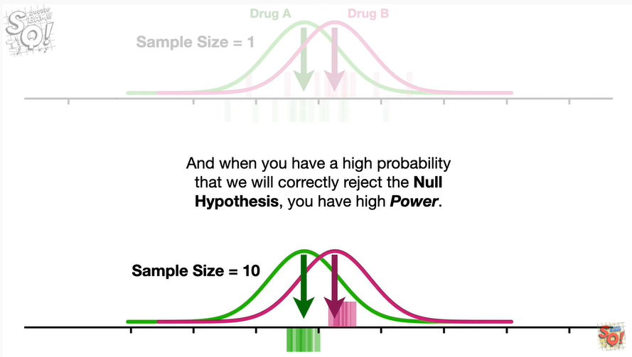

And when you have a high probability that we will correctly reject the null hypothesis you have high power.

Triple bam !!!